**Results**

First of all, calculations of mean scores for both sets of dimensions were computed for each sample that had at least 20 responses (Central, North-Western, Southern, Volga, Ural, and Siberian federal districts) and appear in Table 3 and Table 4. Two federal districts, namely the North Caucasus (4 responses) and the Far East (6 responses), were excluded from the analysis due to the absence of a minimum designated threshold.

|  |  |  |  |  |  |  |  |  |  |  |  |
| --- | --- | --- | --- | --- | --- | --- | --- | --- | --- | --- | --- |
| Table 3. |  | | | Central FD | North-western FD | Southern FD | Volga FD | | Ural FD | | Siberian FD |
| Mean scores for the LBDQ dimensions for the samples | | Representation | | 3.58 | 3.70 | 3.81 | 3.82 | | 3.77 | | 3.67 |
| Demand Reconciliation | | 3.49 | 3.91 | 4.00 | 3.61 | | 3.75 | | 3.74 |
| Tolerance of Uncertainty | | 3.32 | 3.52 | 3.39 | 3.30 | | 3.52 | | 3.32 |
| Persuasiveness | | 3.82 | 3.90 | 4.13 | 3.95 | | 3.98 | | 3.85 |
| Initiation of Structure | | 3.86 | 4.00 | 4.12 | 3.95 | | 4.02 | | 3.95 |
| Tolerance of Freedom | | 3.60 | 3.54 | 3.55 | 3.53 | | 3.62 | | 3.53 |
| Role Assumption | | 3.39 | 3.77 | 3.82 | 3.52 | | 3.57 | | 3.54 |
| Consideration | | 3.65 | 3.77 | 3.87 | 3.76 | | 3.83 | | 3.86 |
| Production Emphasis | | 3.65 | 3.56 | 3.73 | 3.69 | | 3.71 | | 3.67 |
| Prediction Accuracy | | 3.72 | 3.96 | 3.84 | 3.78 | | 3.94 | | 3.84 |
| Integration | | 4.02 | 4.12 | 4.41 | 4.11 | | 4.27 | | 4.10 |
| Superior Orientation | | 3.84 | 3.98 | 3.90 | 3.91 | | 3.89 | | 3.78 |
|  | |  |  |  |  | |  | |  |
|  | Note(s): (Range: maximum 5, minimum 1) | | | | |  | |  | |

|  |  |  |  |  |  |  |  |  |
| --- | --- | --- | --- | --- | --- | --- | --- | --- |
| Table 4. |  | | Central FD | North Western FD | Southern FD | Volga FD | Ural FD | Siberian FD |
| Means scores for Hofstede’s cultural dimensions for the samples | | Power Distance | 39.49 | 38.60 | 32.17 | 37.03 | 40.00 | 44.39 |
| Individualism | 12.41 | 53.20 | 19.78 | 36.19 | 31.61 | 39.24 |
| Masculinity | 5.32 | -2.80 | 4.57 | 3.56 | 0.00 | 2.12 |
| Uncertainty Avoidance | -11.52 | -4.80 | -4.78 | -12.97 | -5.65 | 1.21 |
| Long-Term Orientation | 1.08 | -8.40 | 13.91 | 3.05 | 16.61 | 15.15 |
| Indulgence | 3.86 | 18.20 | 9.13 | 9.66 | 16.13 | 33.03 |
| Monumentalism | 27.22 | 44.60 | 57.83 | 38.05 | 67.10 | 31.21 |

Note(s): (raw, uncentered data was used, hence the negative values in some dimensions and samples)

To verify the relationship between the two concepts, the Pearson, Spearman as well as linear regression correlations were employed to assess the relationship between the aggregated sample mean values on the regional level of six federal districts between the two sets of dimensions. Thus, the following results were obtained:

**Representation**

Based on the given results, we can see that there are no significant or marginally significant correlations between Representation and all of Hofstede's cultural dimensions where the correlations are all weak and not significant, with P-values greater than 0.05. See table 5.

|  |  |  |  |  |
| --- | --- | --- | --- | --- |
| Table 5. |  | |  | Representation |
| Spearman and Pearson Correlations between means of Hofstede’s cultural dimensions and of LBDQ’s Representation in six Federal Districts | | Power Distance | Pearson’s r | -0.57 |
| P-value | 0.24 |
| Spearman’s rho | -0.66 |
| P-value | 0.16 |
| Individualism | Pearson’s r | 0.17 |
| P-value | 0.75 |
| Spearman’s rho | 0.09 |
| P-value | 0.87 |
|  | | Masculinity | Pearson’s r | -0.04 |
|  | | P-value | 0.93 |
|  | | Spearman’s rho | -0.09 |
|  | | P-value | 0.87 |
|  | | Uncertainty Avoidance | Pearson’s r | -0.09 |
|  | | P-value | 0.87 |
|  | | Spearman’s rho | -0.26 |
|  | | P-value | 0.62 |
|  | | Long-Term Orientation | Pearson’s r | 0.33 |
|  | | P-value | 0.52 |
|  | | Spearman’s rho | 0.20 |
|  | | P-value | 0.70 |
|  | | Indulgence | Pearson’s r | -0.09 |
|  | | P-value | 0.86 |
|  | | Spearman’s rho | -0.09 |
|  | | P-value | 0.87 |
|  | | Monumentalism | Pearson’s r | 0.66 |
|  | | P-value | 0.15 |
|  | | Spearman’s rho | 0.60 |
|  | | P-value | 0.21 |

Linear regression analysis was utilized for the samples as well as a visualization of the regression models was performed to better understand the results (see figures 1-7):

Figure 1. Representation and Power Distance

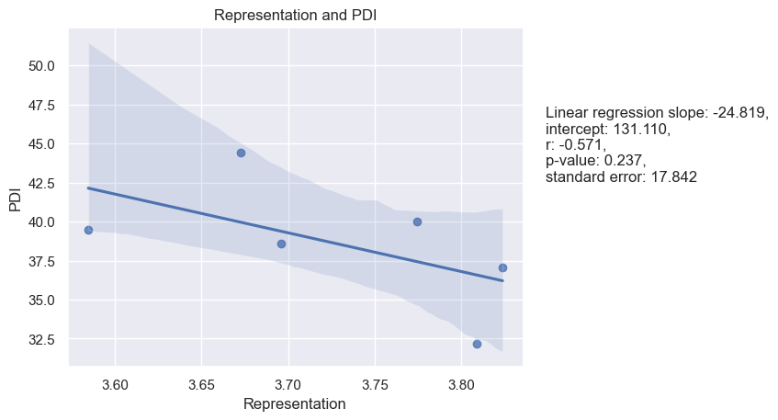

Figure 2. Representation and Individualism

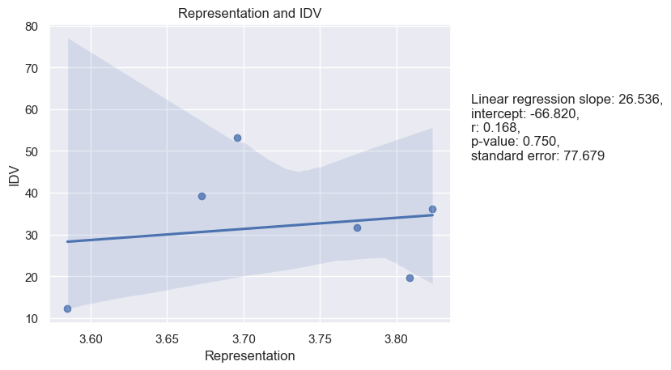

Figure 3. Representation and Masculinity

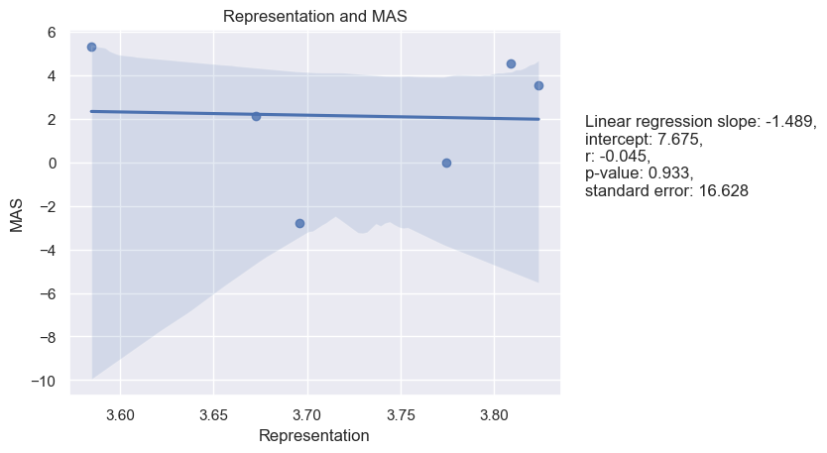

Figure 4. Representation and Uncertainty Avoidance

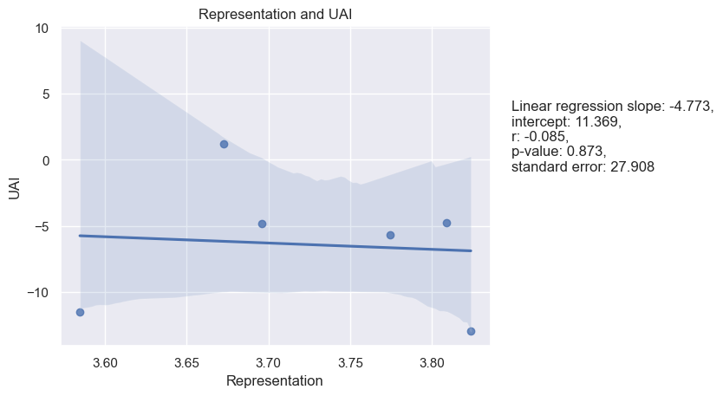

Figure 5. Representation and Long-Term Orientation

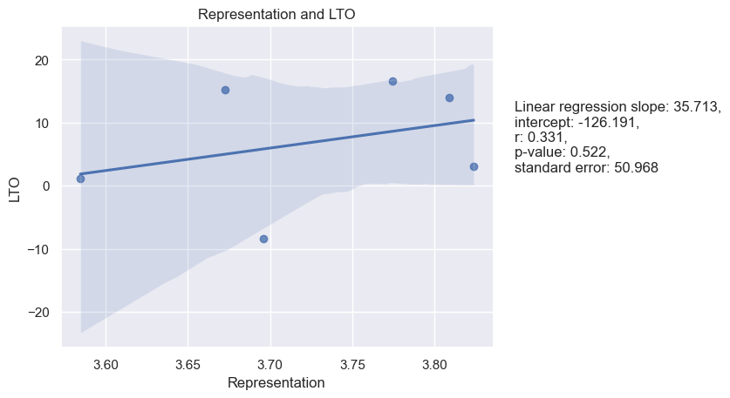

Figure 6. Representation and Indulgence

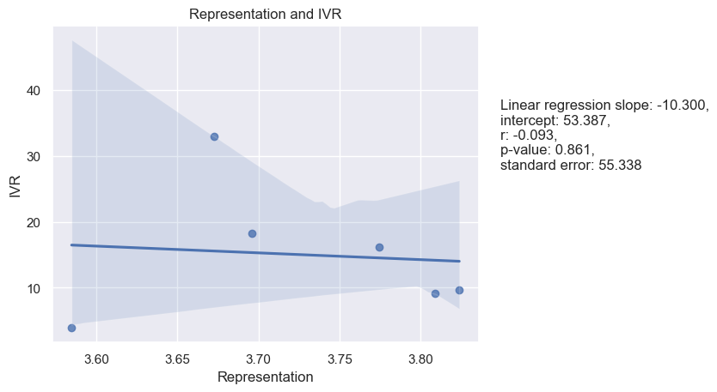

Figure 7. Representation and Monumentalism

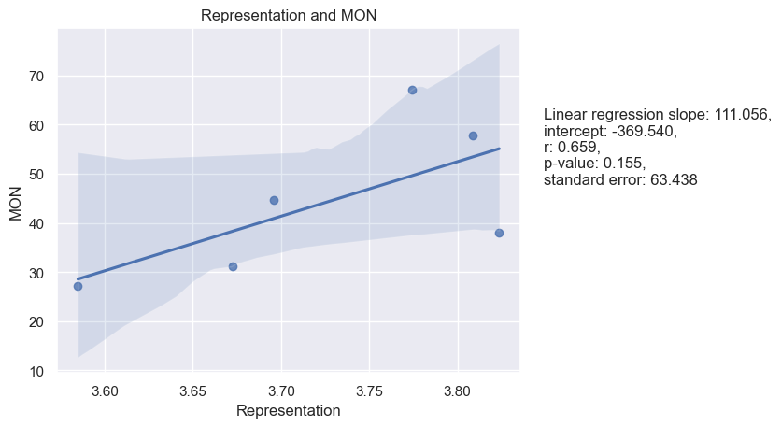

**Reconciliation**

Based on several correlations and linear regressions conducted to analyze the relationship between the Reconciliation dimension of LBDQ and Hofstede's cultural dimensions, the only marginally significant correlation was between Reconciliation and UAI and Reconciliation and MON, with a Pearson correlation of 0.58 and a P-value of 0.23 and 0.62, a P-value of 0.19 accordingly. There were no significant correlations found with PDI, IDV, MAS, LTO, IVR, and MON. The linear regression analysis did not yield significant results either. See Table 6.

|  |  |  |  |  |
| --- | --- | --- | --- | --- |
| Table 6. |  | |  | Reconciliation |
| Spearman and Pearson Correlations between means of Hofstede’s cultural dimensions and of LBDQ’s Reconciliation in six Federal Districts | | Power Distance | Pearson’s r | -0.45 |
| P-value | 0.37 |
| Spearman’s rho | -0.37 |
| P-value | 0.47 |
| Individualism | Pearson’s r | 0.35 |
| P-value | 0.49 |
| Spearman’s rho | 0.26 |
| P-value | 0.62 |
|  | | Masculinity | Pearson’s r | -0.42 |
|  | | P-value | 0.40 |
|  | | Spearman’s rho | -0.43 |
|  | | P-value | 0.40 |
|  | | Uncertainty Avoidance | Pearson’s r | 0.58 |
|  | | P-value | 0.23 |
|  | | Spearman’s rho | 0.60 |
|  | | P-value | 0.21 |
|  | | Long-Term Orientation | Pearson’s r | 0.14 |
|  | | P-value | 0.80 |
|  | | Spearman’s rho | 0.14 |
|  | | P-value | 0.79 |
|  | | Indulgence | Pearson’s r | 0.26 |
|  | | P-value | 0.62 |
|  | | Spearman’s rho | 0.26 |
|  | | P-value | 0.62 |
|  | | Monumentalism | Pearson’s r | 0.62 |
|  | | P-value | 0.19 |
|  | | Spearman’s rho | 0.77 |
|  | | P-value | 0.07 |

Linear regression analysis and its visualization are presented below (see figures 8-14):

Figure 8. Reconciliation and Power Distance

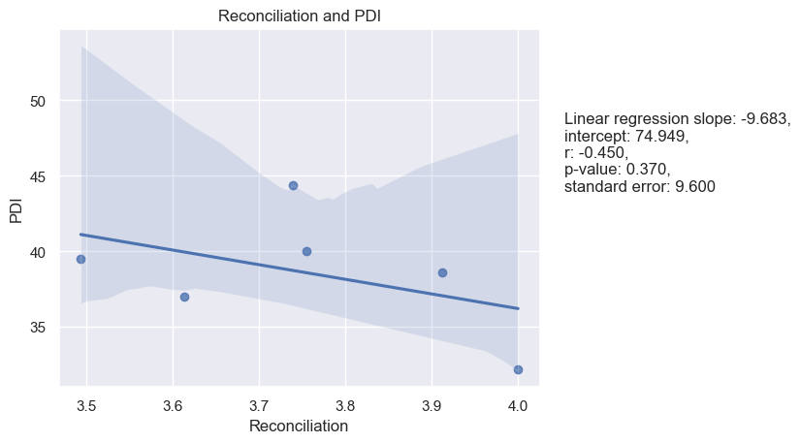

Figure 9. Reconciliation and Individualism

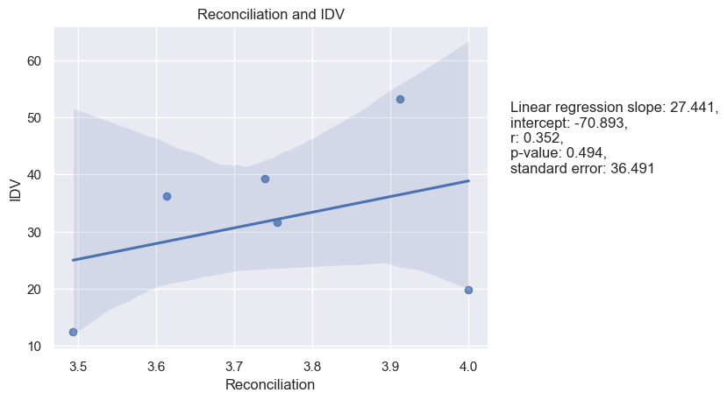

Figure 10. Reconciliation and Masculinity

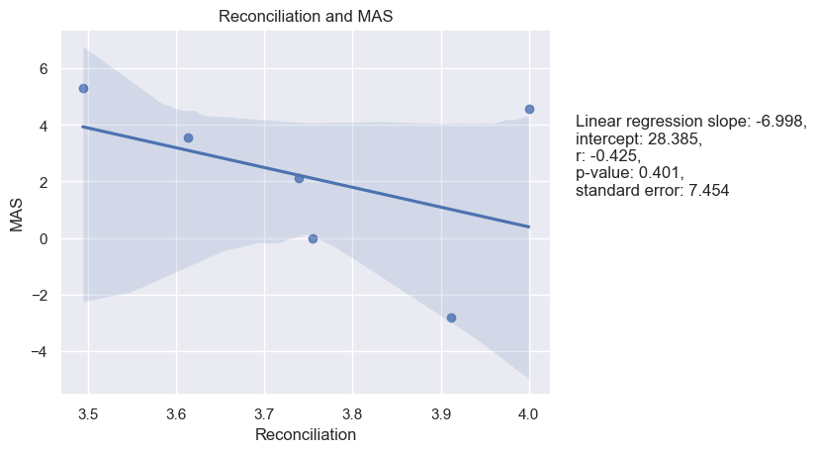

Figure 11. Reconciliation and Uncertainty Avoidance

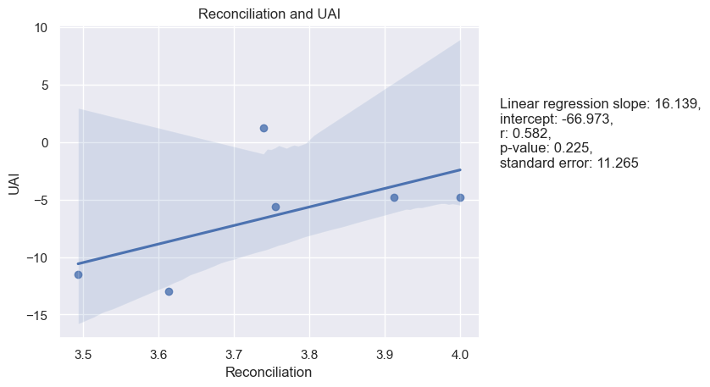

Figure 12. Reconciliation and Long-Term Orientation

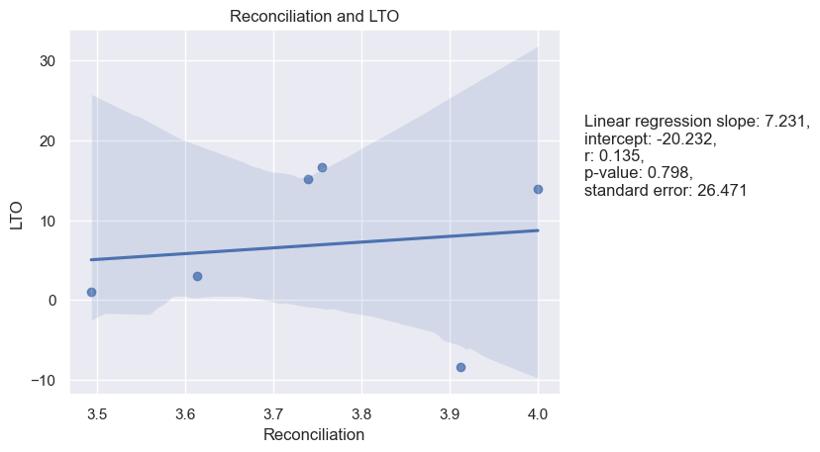

Figure 13. Reconciliation and Indulgence

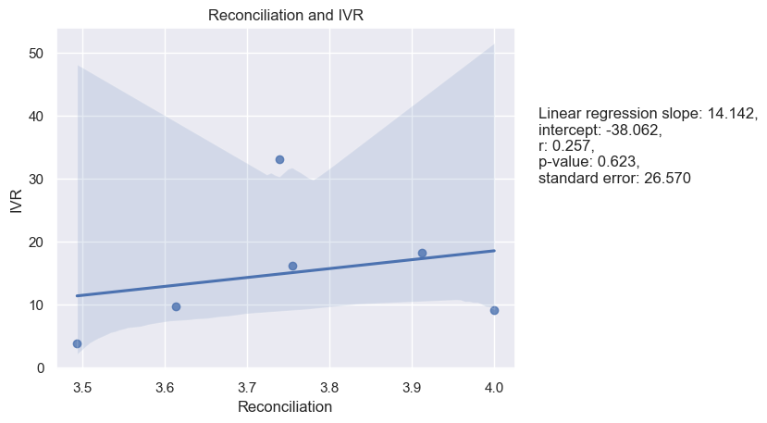

Figure 14. Reconciliation and Monumentalism

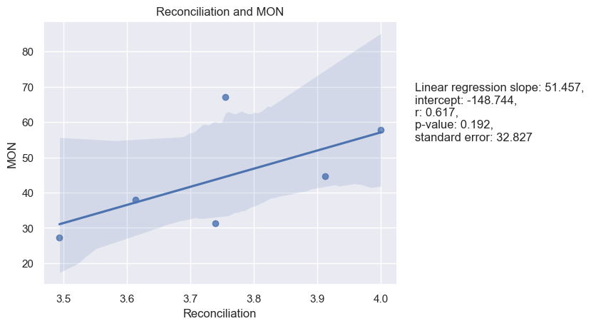

**Tolerance of Uncertainty and Hofstede’s dimensions**

There is a marginally significant negative correlation between Tolerance of Uncertainty and MAS with both Pearson and Spearman correlation coefficients are quite large (-0.82 and -0.71, respectively), indicating a strong negative correlation. This is also supported by the linear regression analysis, where the p-value (0.044) is less than 0.05. All other correlations are not significant, including those with PDI, IDV, UAI, LTO, IVR, and MON. See Table 7.

|  |  |  |  |  |
| --- | --- | --- | --- | --- |
| Table 7. |  | |  | Tolerance of Uncertainty |
| Spearman and Pearson Correlations between means of Hofstede’s cultural dimensions and of LBDQ’s Tolerance of Uncertainty in six Federal Districts | | Power Distance | Pearson’s r | -0.07 |
| P-value | 0.89 |
| Spearman’s rho | 0.09 |
| P-value | 0.87 |
| Individualism | Pearson’s r | 0.45 |
| P-value | 0.37 |
| Spearman’s rho | 0.37 |
| P-value | 0.47 |
|  | | Masculinity | Pearson’s r | -0.82 |
|  | | P-value | 0.04 |
|  | | Spearman’s rho | -0.71 |
|  | | P-value | 0.11 |
|  | | Uncertainty Avoidance | Pearson’s r | 0.27 |
|  | | P-value | 0.60 |
|  | | Spearman’s rho | 0.49 |
|  | | P-value | 0.33 |
|  | | Long-Term Orientation | Pearson’s r | -0.11 |
|  | | P-value | 0.83 |
|  | | Spearman’s rho | 0.03 |
|  | | P-value | 0.96 |
|  | | Indulgence | Pearson’s r | 0.11 |
|  | | P-value | 0.83 |
|  | | Spearman’s rho | 0.43 |
|  | | P-value | 0.40 |
|  | | Monumentalism | Pearson’s r | 0.72 |
|  | | P-value | 0.11 |
|  | | Spearman’s rho | 0.66 |
|  | | P-value | 0.16 |

Linear regression analysis was performed as well. See Figures 15-21:

Figure 15. Tolerance of Uncertainty and Power Distance

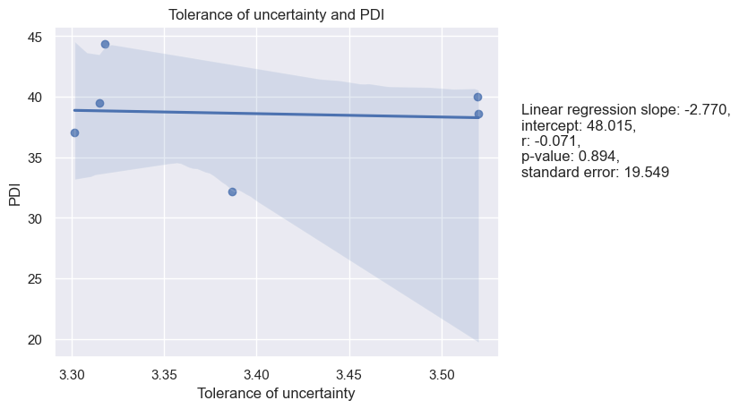

Figure 16. Tolerance of Uncertainty and Individualism

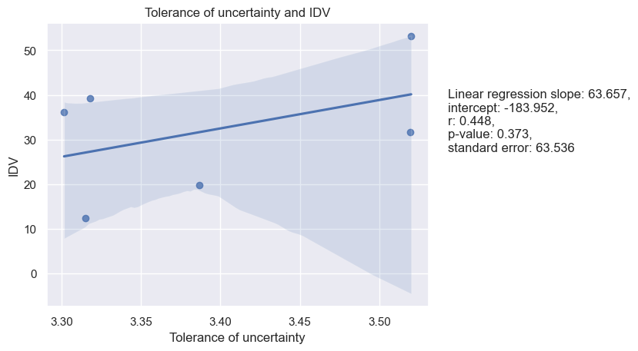

Figure 17. Tolerance of Uncertainty and Masculinity

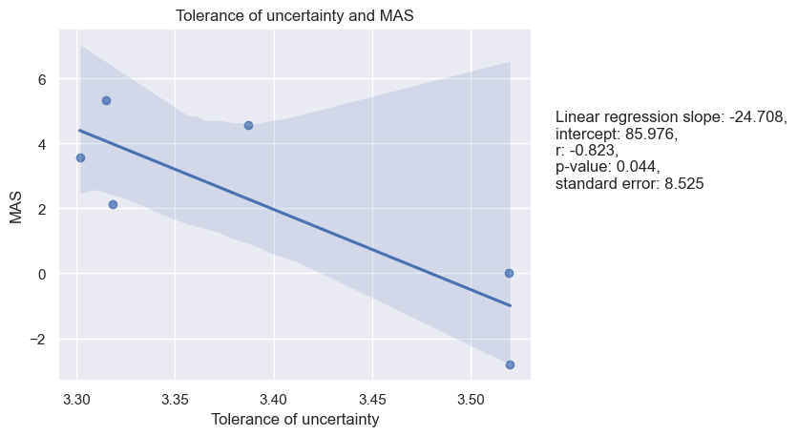

Figure 18. Tolerance of Uncertainty and Uncertainty Avoidance

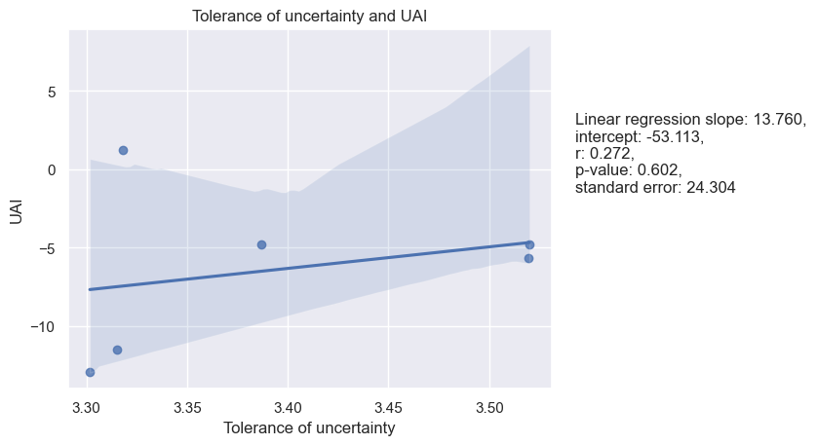

Figure 19. Tolerance of Uncertainty and Long-Term Orientation

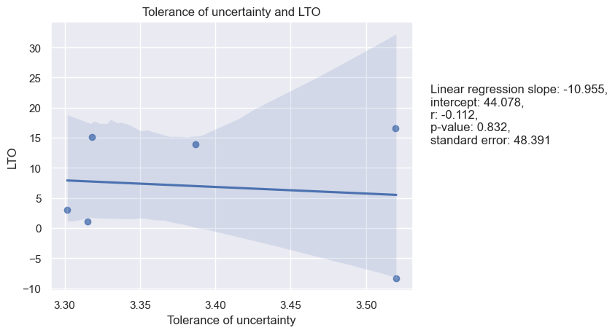

Figure 20. Tolerance of Uncertainty and Indulgence

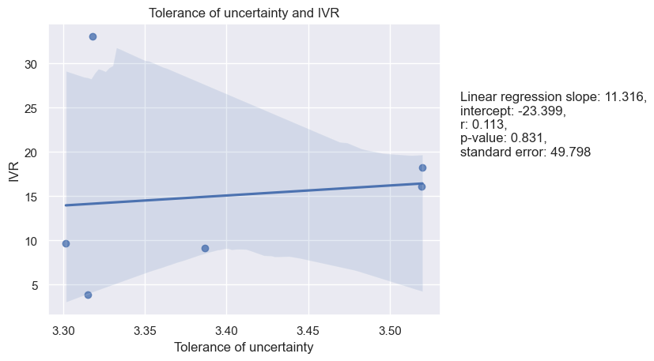

Figure 21. Tolerance of Uncertainty and Monumentalism

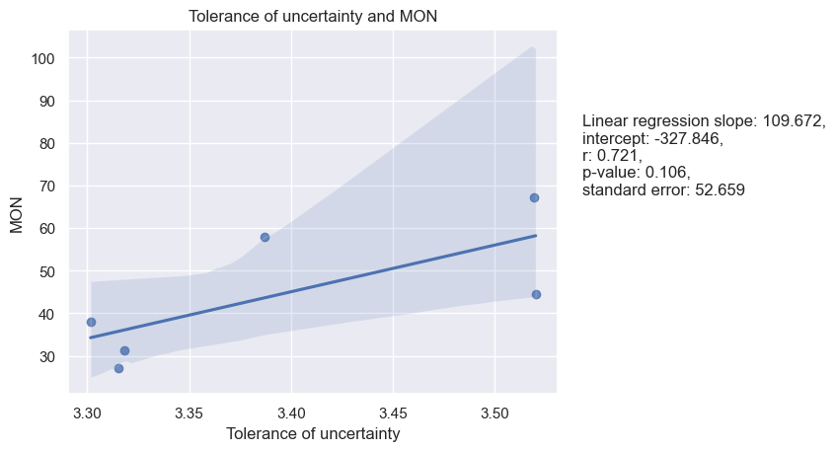

**Persuasiveness and Hofstede’s dimensions**

Based on the given results, the significant correlations observed are between Persuasiveness and MON, where both Pearson and Spearman correlations are relatively high, 0.76 and 0.89 respectively, with the linear regression analysis indicates a marginally significant p-value of 0.079, and between Persuasiveness and PDI, with a Pearson correlation coefficient of -0.81 and a p-value of 0.05. This means that as Persuasiveness increases, PDI tends to decrease. The linear regression model also shows a negative slope of -29.397, suggesting that for each unit increase in Persuasiveness, PDI decreases by 29.397, holding all other variables constant. For the other cultural dimensions, there is no significant correlation between Persuasiveness and IDV, MAS, UAI, LTO, and IVR, as the p-values for Pearson and Spearman correlations, as well as linear regression analyses are above the common threshold of 0.05. See Table 8.

|  |  |  |  |  |
| --- | --- | --- | --- | --- |
| Table 8. |  | |  | Persuasiveness |
| Spearman and Pearson Correlations between means of Hofstede’s cultural dimensions and of LBDQ’s Persuasiveness in six Federal Districts | | Power Distance | Pearson’s r | -0.81 |
| P-value | 0.05 |
| Spearman’s rho | -0.54 |
| P-value | 0.27 |
| Individualism | Pearson’s r | -0.21 |
| P-value | 0.68 |
| Spearman’s rho | -0.09 |
| P-value | 0.87 |
|  | | Masculinity | Pearson’s r | 0.16 |
|  | | P-value | 0.76 |
|  | | Spearman’s rho | -0.14 |
|  | | P-value | 0.79 |
|  | | Uncertainty Avoidance | Pearson’s r | 0.03 |
|  | | P-value | 0.95 |
|  | | Spearman’s rho | 0.09 |
|  | | P-value | 0.87 |
|  | | Long-Term Orientation | Pearson’s r | 0.44 |
|  | | P-value | 0.39 |
|  | | Spearman’s rho | 0.43 |
|  | | P-value | 0.40 |
|  | | Indulgence | Pearson’s r | -0.28 |
|  | | P-value | 0.59 |
|  | | Spearman’s rho | -0.09 |
|  | | P-value | 0.97 |
|  | | Monumentalism | Pearson’s r | 0.76 |
|  | | P-value | 0.08 |
|  | | Spearman’s rho | 0.89 |
|  | | P-value | 0.02 |

Linear regression analysis for the samples as well as a visualization of the regression models are presented below (see figures 22-28):

Figure 22. Persuasiveness and Power Distance

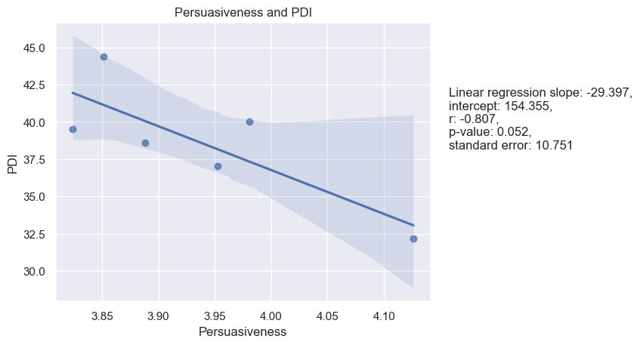

Figure 23. Persuasiveness and Individualism

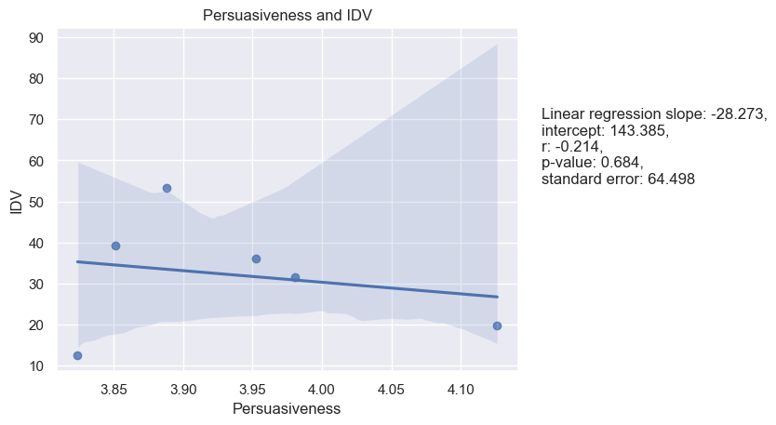

Figure 24. Persuasiveness and Masculinity

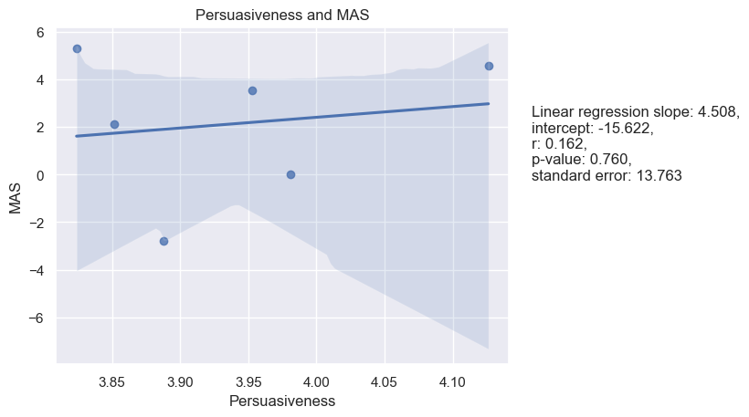

Figure 25. Persuasiveness and Uncertainty Avoidance

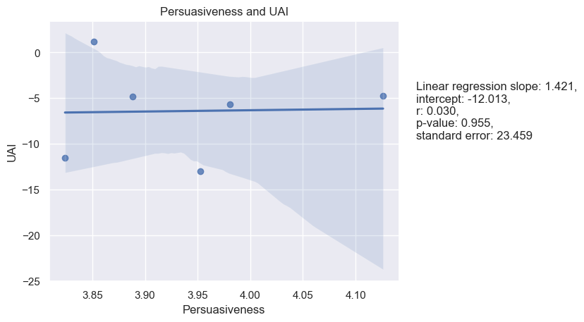

Figure 26. Persuasiveness and Long-Term Orientation

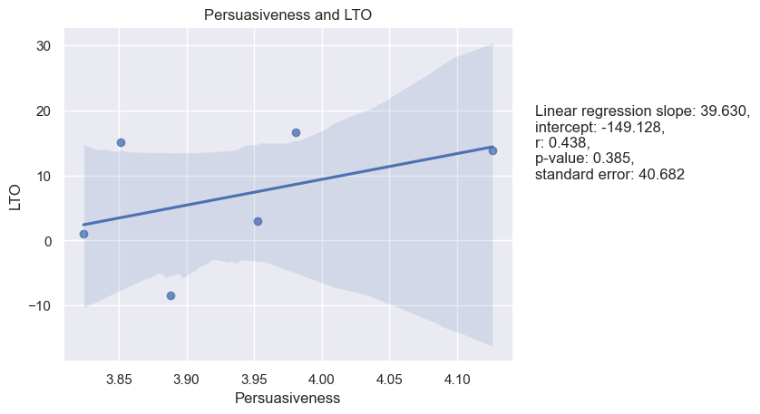

Figure 27. Persuasiveness and Indulgence

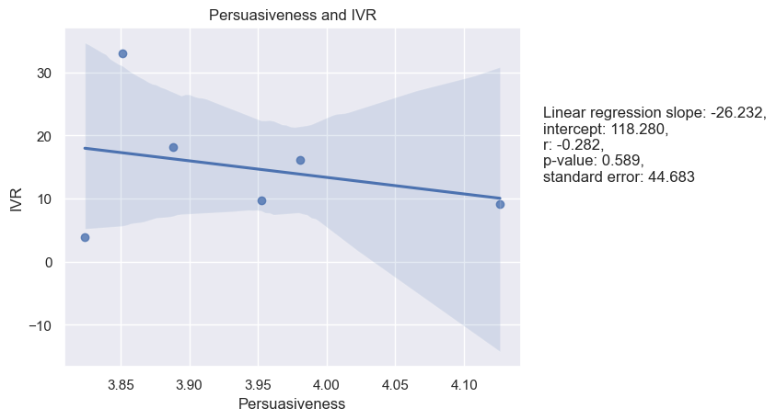

Figure 28. Persuasiveness and Monumentalism

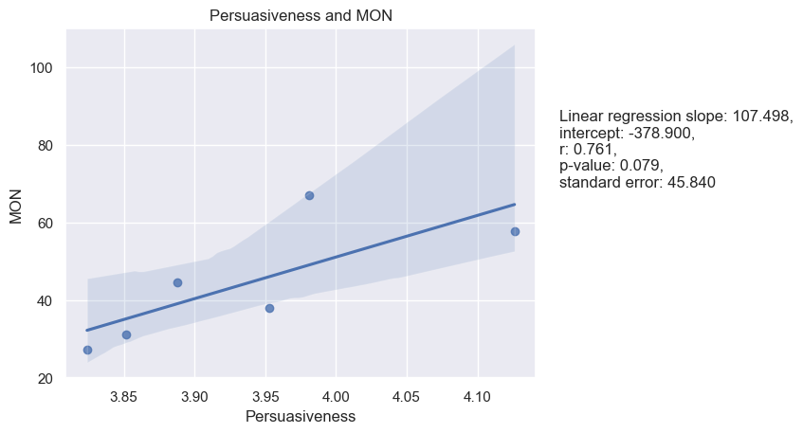

**Initiation of Structure and Hofstede’s dimensions:**

Starting with the non-significant results, the correlation coefficients between Initiation of Structure and PDI, IDV, MAS, UAI, LTO, and IVR are not significant at the 0.05 level. The p-values for these correlations are greater than 0.05, indicating that there is insufficient evidence to conclude that these correlations are statistically significant. However, there is a positive correlation between Initiation of Structure and MON, as shown by both the Pearson (0.82) and Spearman (0.89) correlation coefficients. The linear regression analysis also supports this finding, with a positive slope (144.118) and a positive correlation coefficient (0.819). The p-value for the correlation coefficient is below the 0.05 level, indicating that the relationship is statistically significant. See Table 9.

|  |  |  |  |  |
| --- | --- | --- | --- | --- |
| Table 9. |  | |  | Initiation of Structure |
| Spearman and Pearson Correlations between means of Hofstede’s cultural dimensions and of LBDQ’s Initiation of Structure in six Federal Districts | | Power Distance | Pearson’s r | -0.61 |
| P-value | 0.20 |
| Spearman’s rho | -0.26 |
| P-value | 0.62 |
| Individualism | Pearson’s r | 0.11 |
| P-value | 0.84 |
| Spearman’s rho | 0.09 |
| P-value | 0.87 |
|  | | Masculinity | Pearson’s r | -0.21 |
|  | | P-value | 0.69 |
|  | | Spearman’s rho | -0.37 |
|  | | P-value | 0.47 |
|  | | Uncertainty Avoidance | Pearson’s r | 0.40 |
|  | | P-value | 0.43 |
|  | | Spearman’s rho | 0.54 |
|  | | P-value | 0.27 |
|  | | Long-Term Orientation | Pearson’s r | 0.39 |
|  | | P-value | 0.44 |
|  | | Spearman’s rho | 0.43 |
|  | | P-value | 0.40 |
|  | | Indulgence | Pearson’s r | 0.06 |
|  | | P-value | 0.90 |
|  | | Spearman’s rho | 0.20 |
|  | | P-value | 0.70 |
|  | | Monumentalism | Pearson’s r | 0.82 |
|  | | P-value | 0.05 |
|  | | Spearman’s rho | 0.89 |
|  | | P-value | 0.02 |

Linear regression analysis for the samples as well as a visualization of the regression models are presented below (see figures 29-35):

Figure 29. Initiation of Structure and Power Distance

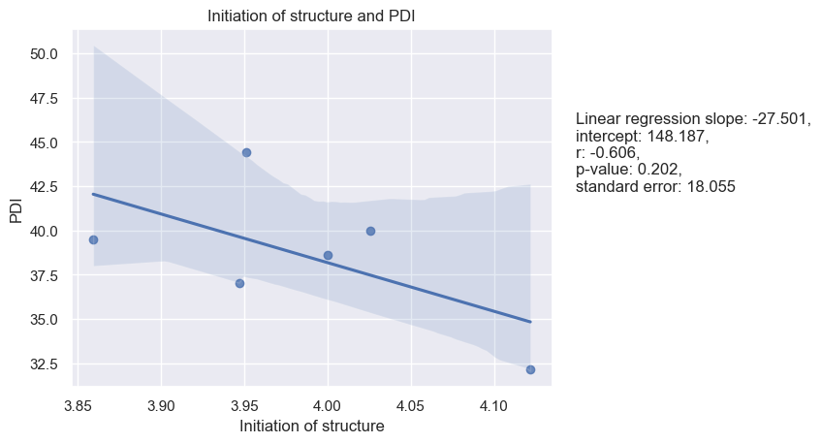

Figure 30. Initiation of Structure and Individualism

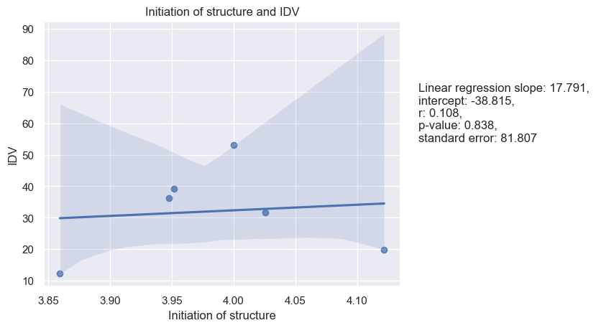

Figure 31. Initiation of Structure and Masculinity

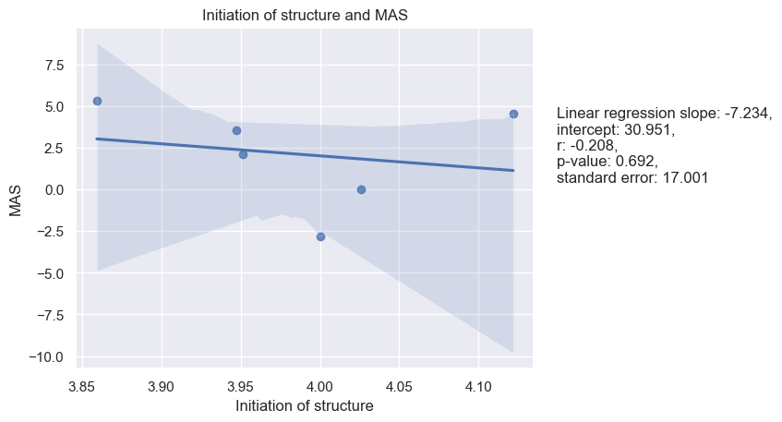

Figure 32. Initiation of Structure and Uncertainty Avoidance

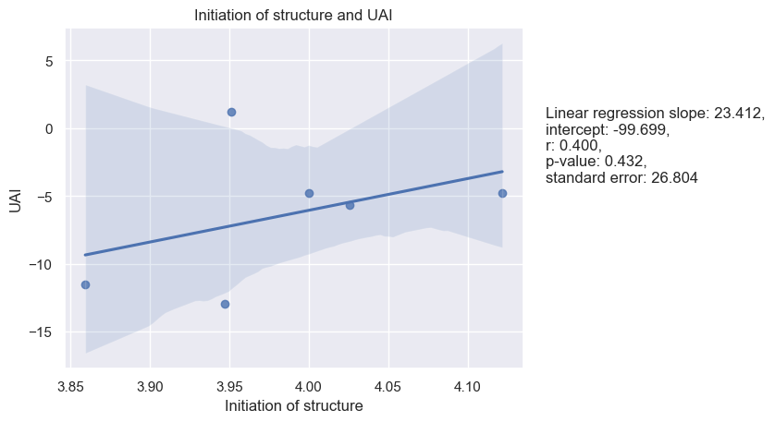

Figure 33. Initiation of Structure and Long-Term Orientation

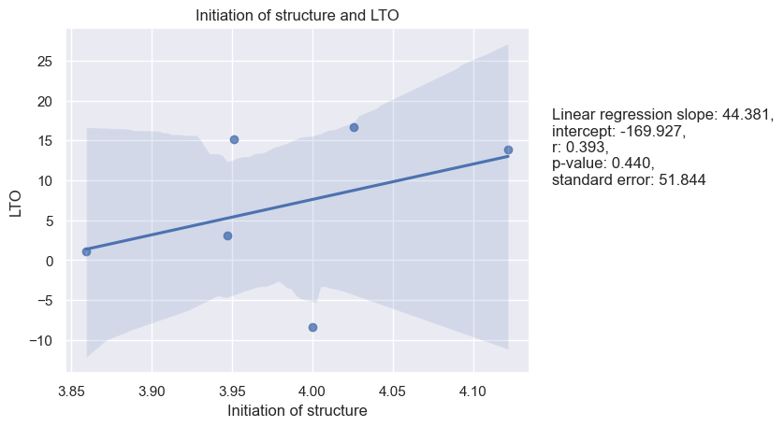

Figure 34. Initiation of Structure and Indulgence

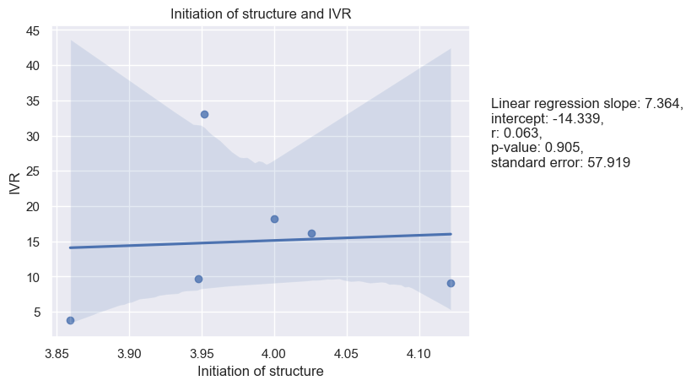

Figure 35. Initiation of Structure and Monumentalism

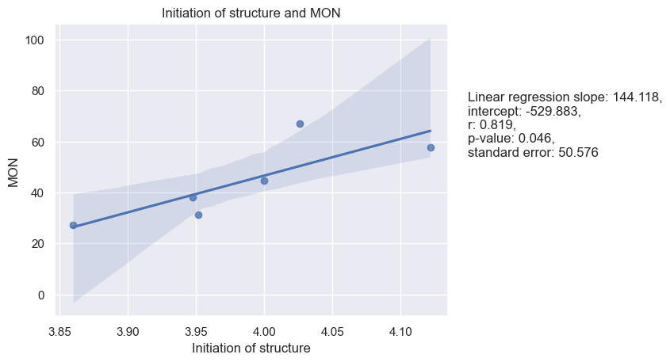

**Tolerance of Freedom and Hofstede’s dimensions**

Based on the provided results, it appears that there are no significant or marginally significant results in the correlations and linear regression analyses between Tolerance and Freedom and any of Hofstede's cultural dimensions. While the lack of significant results may be disappointing, it is important to report both significant and non-significant results to provide a complete and accurate picture of the data analysis. The Pearson correlation coefficients for Tolerance and Freedom and PDI, MAS, UAI, LTO, IVR, and MON are 0.11, 0.07, -0.26, 0.23, -0.38, and 0.33, respectively. See Table 10.

|  |  |  |  |  |
| --- | --- | --- | --- | --- |
| Table 10. |  | |  | Tolerance of Freedom |
| Spearman and Pearson Correlations between means of Hofstede’s cultural dimensions and of LBDQ’s Tolerance of Freedom in six Federal Districts | | Power Distance | Pearson’s r | 0.11 |
| P-value | 0.83 |
| Spearman’s rho | -0.03 |
| P-value | 0.96 |
| Individualism | Pearson’s r | -0.52 |
| P-value | 0.29 |
| Spearman’s rho | -0.66 |
| P-value | 0.16 |
|  | | Masculinity | Pearson’s r | 0.07 |
|  | | P-value | 0.89 |
|  | | Spearman’s rho | 0.14 |
|  | | P-value | 0.79 |
|  | | Uncertainty Avoidance | Pearson’s r | -0.26 |
|  | | P-value | 0.62 |
|  | | Spearman’s rho | -0.31 |
|  | | P-value | 0.54 |
|  | | Long-Term Orientation | Pearson’s r | 0.23 |
|  | | P-value | 0.66 |
|  | | Spearman’s rho | 0.14 |
|  | | P-value | 0.79 |
|  | | Indulgence | Pearson’s r | -0.38 |
|  | | P-value | 0.46 |
|  | | Spearman’s rho | -0.54 |
|  | | P-value | 0.27 |
|  | | Monumentalism | Pearson’s r | 0.33 |
|  | | P-value | 0.53 |
|  | | Spearman’s rho | 0.43 |
|  | | P-value | 0.40 |

Linear regression analysis was performed as well. See Figures 36-42:

Figure 36. Tolerance of Freedom and Power Distance

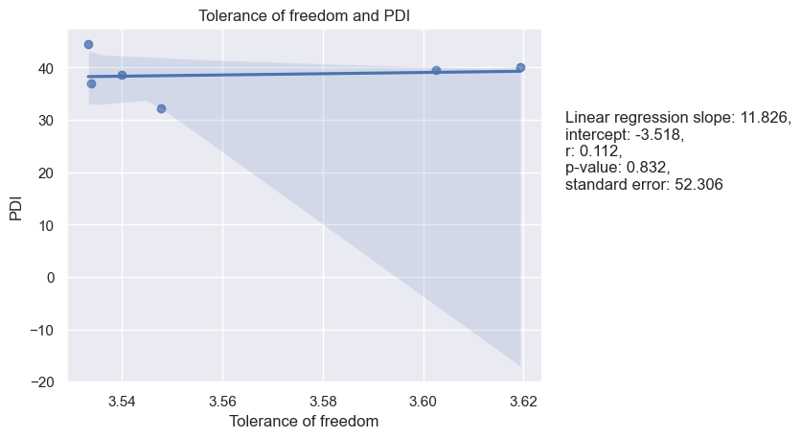

Figure 37. Tolerance of Freedom and Individualism

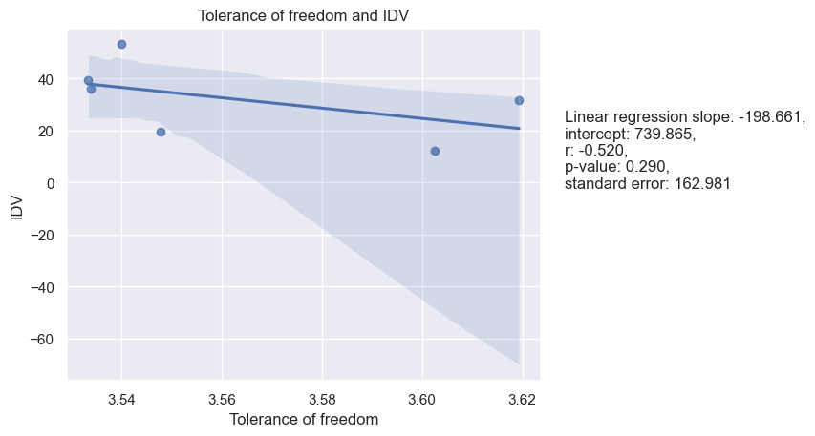

Figure 38. Tolerance of Freedom and Masculinity

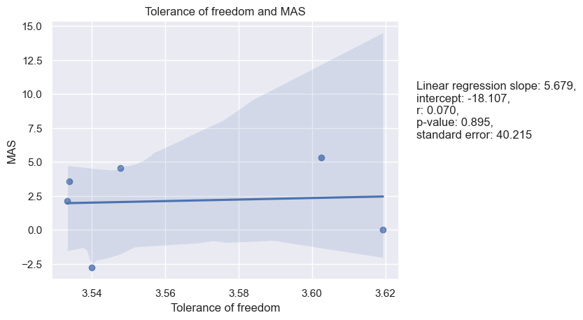

Figure 39. Tolerance of Freedom and Uncertainty Avoidance

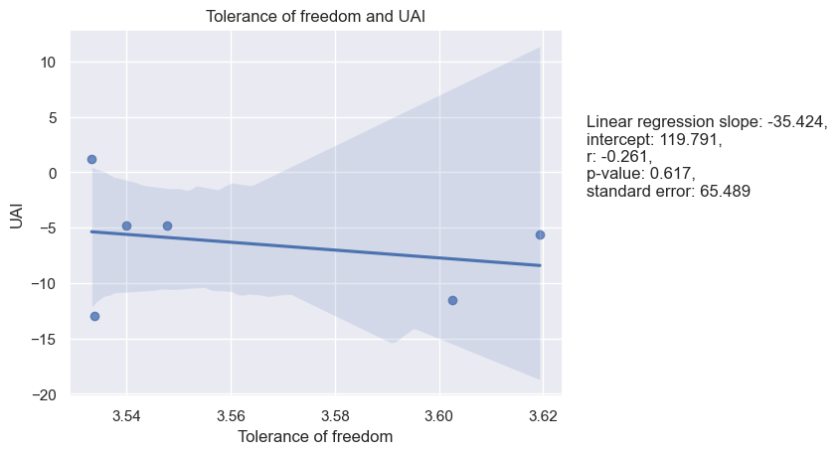

Figure 40. Tolerance of Freedom and Long-Term Orientation

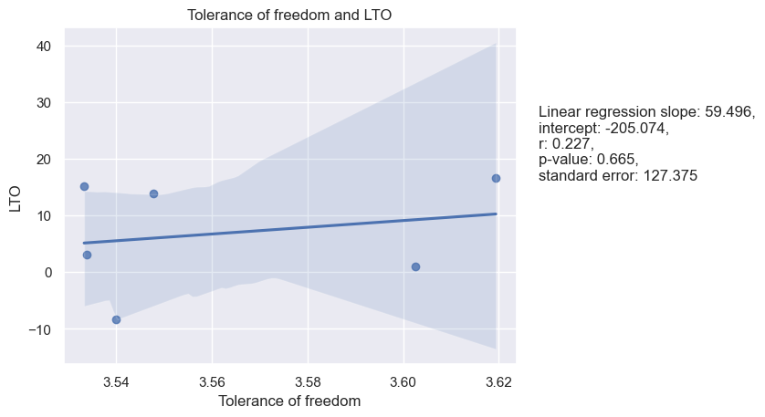

Figure 41. Tolerance of Freedom and Indulgence

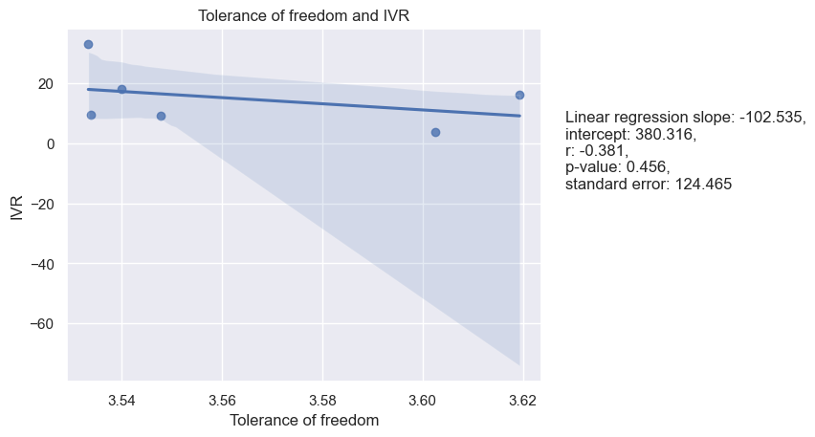

Figure 42. Tolerance of Freedom and Monumentalism

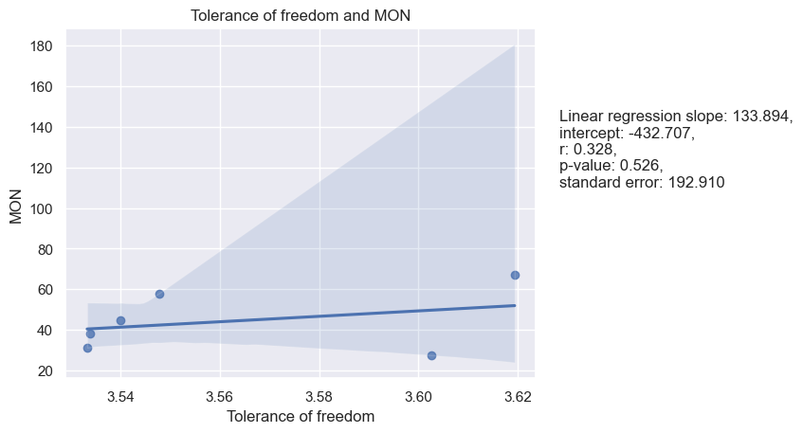

**Role assumption and Hofstede’s dimensions**

The results of the Pearson and Spearman correlation tests, as well as the linear regression analysis, indicate that there are no statistically significant relationships between the Role Assumption dimension of LBDQ and Hofstede's cultural dimensions, except for a marginally significant negative correlation with PDI (Pearson: -0.57, P-val: 0.24; Spearman: -0.37, P-val: 0.47) and a marginally significant positive correlation with MON (Pearson: 0.57, P-val: 0.24; Spearman: 0.77, P-val: 0.07). See table 11.

|  |  |  |  |  |
| --- | --- | --- | --- | --- |
| Table 11. |  | |  | Role Assumption |
| Spearman and Pearson Correlations between means of Hofstede’s cultural dimensions and of LBDQ’s Role Assumption in six Federal Districts | | Power Distance | Pearson’s r | -0.57 |
| P-value | 0.24 |
| Spearman’s rho | -0.37 |
| P-value | 0.47 |
| Individualism | Pearson’s r | 0.37 |
| P-value | 0.47 |
| Spearman’s rho | 0.26 |
| P-value | 0.62 |
|  | | Masculinity | Pearson’s r | -0.41 |
|  | | P-value | 0.42 |
|  | | Spearman’s rho | -0.43 |
|  | | P-value | 0.40 |
|  | | Uncertainty Avoidance | Pearson’s r | 0.42 |
|  | | P-value | 0.41 |
|  | | Spearman’s rho | 0.60 |
|  | | P-value | 0.21 |
|  | | Long-Term Orientation | Pearson’s r | -0.04 |
|  | | P-value | 0.95 |
|  | | Spearman’s rho | 0.14 |
|  | | P-value | 0.79 |
|  | | Indulgence | Pearson’s r | 0.12 |
|  | | P-value | 0.82 |
|  | | Spearman’s rho | 0.26 |
|  | | P-value | 0.62 |
|  | | Monumentalism | Pearson’s r | 0.57 |
|  | | P-value | 0.24 |
|  | | Spearman’s rho | 0.77 |
|  | | P-value | 0.07 |

In addition to both Spearman and Pearson correlations, linear regression was also performed. See Figures 43-49.

Figure 43. Role Assumption and Power Distance

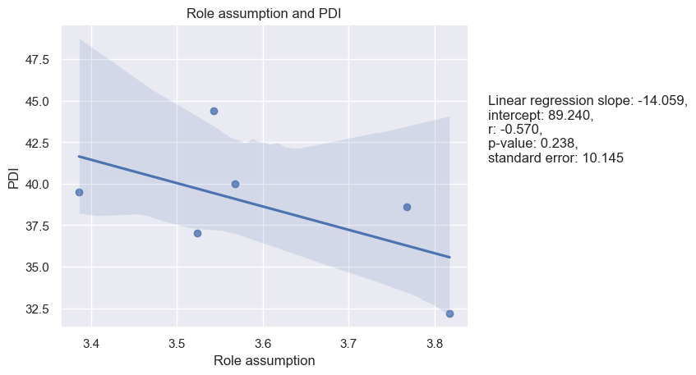

Figure 44. Role Assumption and Individualism

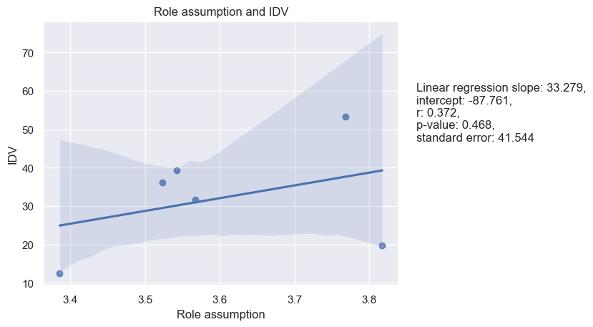

Figure 45. Role Assumption and Masculinity

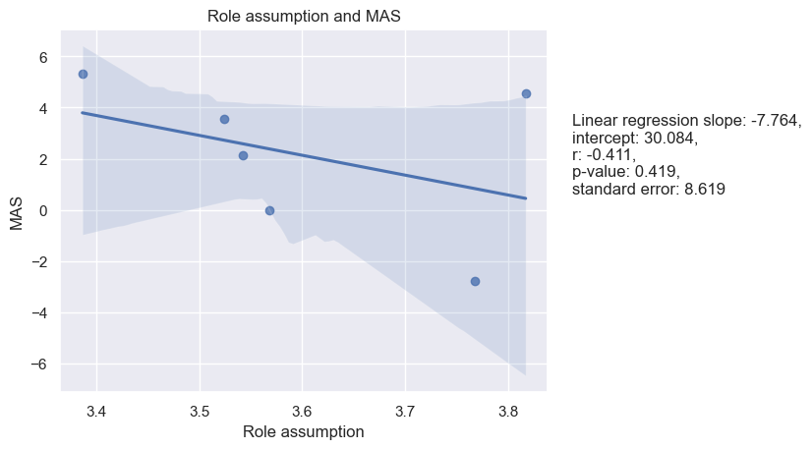

Figure 46. Role Assumption and Uncertainty Avoidance

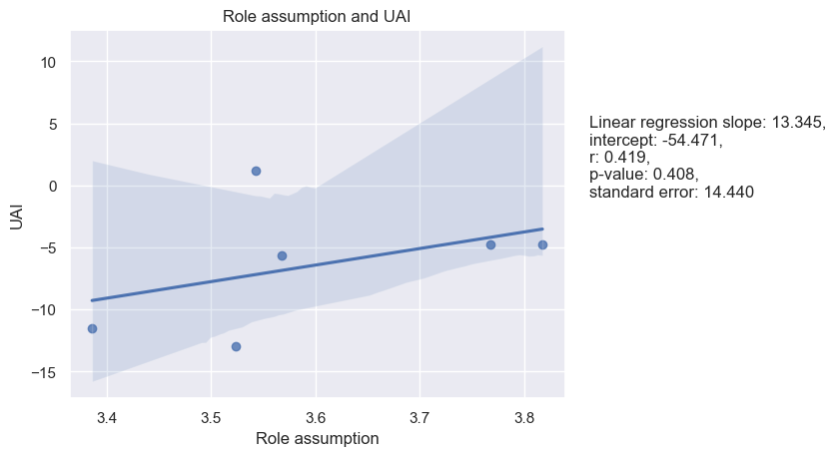

Figure 47. Role Assumption and Long-Term Orientation

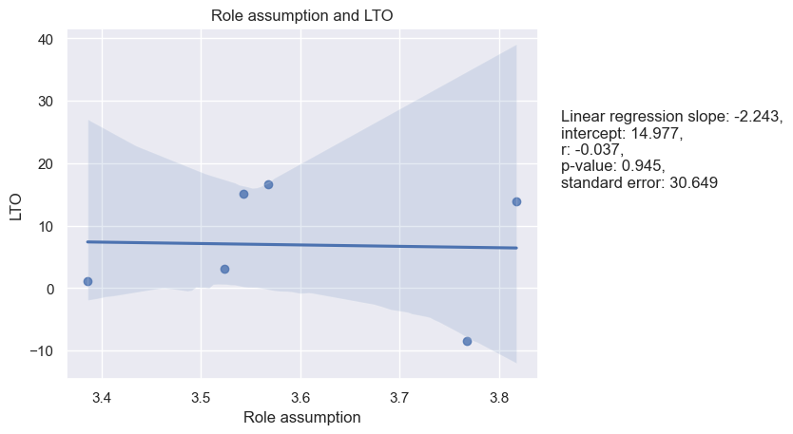

Figure 48. Role Assumption and Indulgence

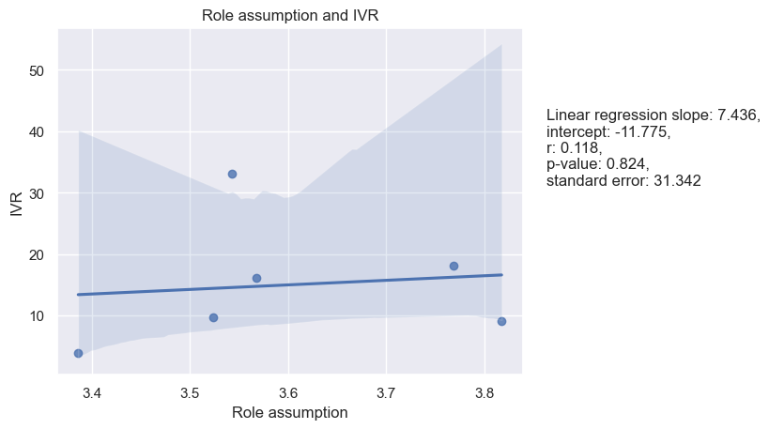

Figure 49. Role Assumption and Monumentalism

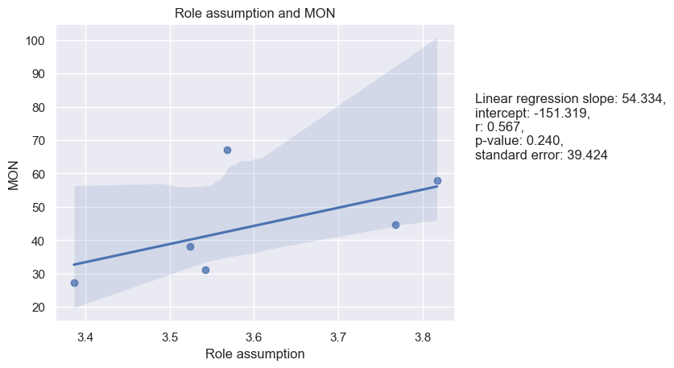

**Consideration and Hofstede’s dimensions**

There is a positive correlation between Consideration and UAI, with a Pearson correlation of 0.75 and a Spearman correlation of 0.83 with p-values of 0.09 and 0.04 accrodingly. The linear regression slope is positive (47.133), indicating that as UAI increases, so does Consideration. The p-value for the linear regression is 0.086, which is marginally significant. This suggests that there may be some relationship between a leader's Consideration and a culture's level of uncertainty avoidance, although further investigation is needed to determine the nature of this relationship. However, the analysis shows that there is no significant correlation or regression between Consideration and PDI, IDV, MAS, LTO, IVR, and MON dimensions. See Table 12.

|  |  |  |  |  |
| --- | --- | --- | --- | --- |
| Table 12. |  | |  | Consideration |
| Spearman and Pearson Correlations between means of Hofstede’s cultural dimensions and of LBDQ’s Consideration in six Federal Districts | | Power Distance | Pearson’s r | -0.08 |
| P-value | 0.87 |
| Spearman’s rho | -0.03 |
| P-value | 0.96 |
| Individualism | Pearson’s r | 0.29 |
| P-value | 0.58 |
| Spearman’s rho | 0.14 |
| P-value | 0.79 |
|  | | Masculinity | Pearson’s r | -0.24 |
|  | | P-value | 0.65 |
|  | | Spearman’s rho | -0.20 |
|  | | P-value | 0.70 |
|  | | Uncertainty Avoidance | Pearson’s r | 0.75 |
|  | | P-value | 0.09 |
|  | | Spearman’s rho | 0.83 |
|  | | P-value | 0.04 |
|  | | Long-Term Orientation | Pearson’s r | 0.67 |
|  | | P-value | 0.15 |
|  | | Spearman’s rho | 0.60 |
|  | | P-value | 0.21 |
|  | | Indulgence | Pearson’s r | 0.59 |
|  | | P-value | 0.22 |
|  | | Spearman’s rho | 0.37 |
|  | | P-value | 0.47 |
|  | | Monumentalism | Pearson’s r | 0.58 |
|  | | P-value | 0.23 |
|  | | Spearman’s rho | 0.54 |
|  | | P-value | 0.27 |

Linear regression analysis for the samples as well as a visualization of the regression models are presented below (see figures 50-56):

Figure 50. Consideration and Power Distance

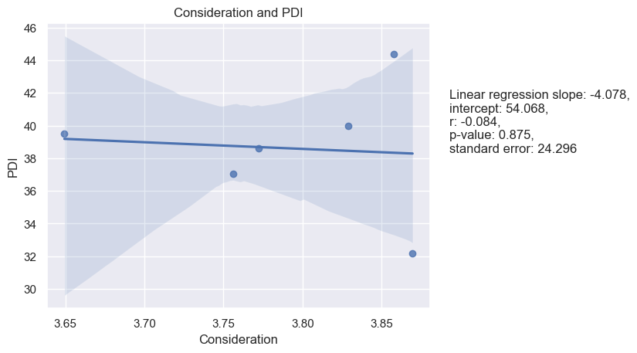

Figure 51. Consideration and Individualism

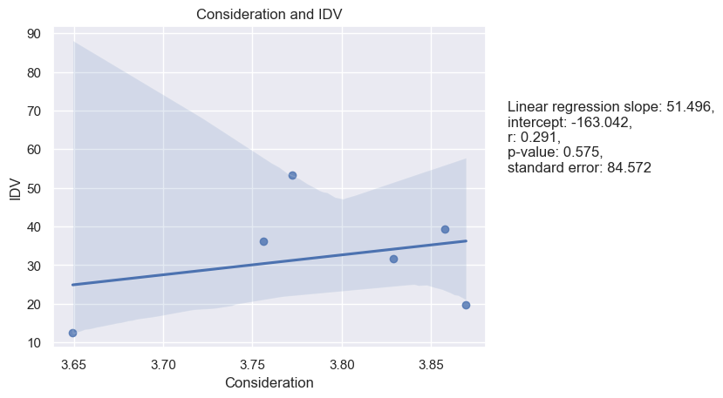

Figure 52. Consideration and Masculinity

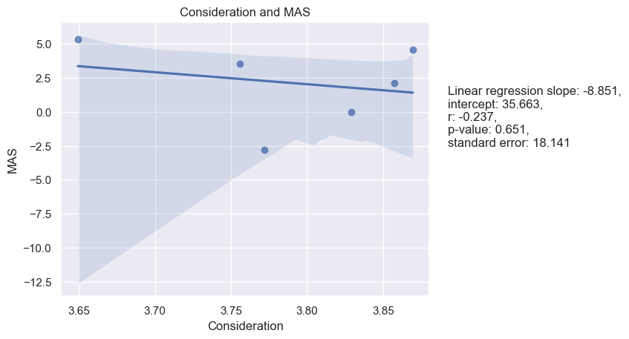

Figure 53. Consideration and Uncertainty Avoidance

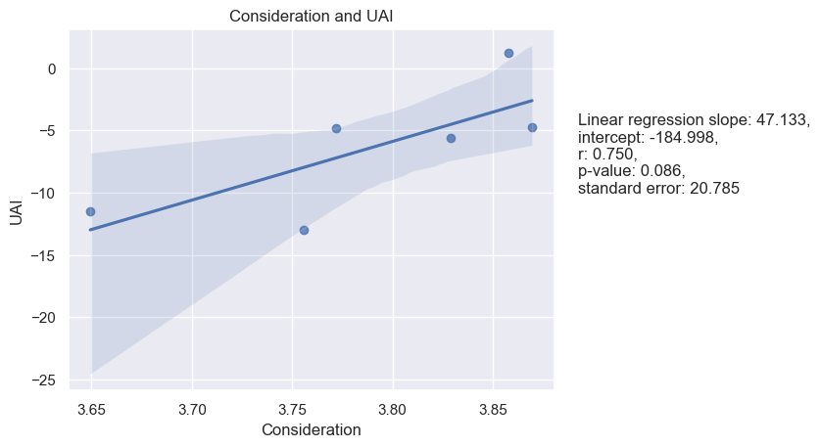

Figure 54. Consideration and Long-Term Orientation

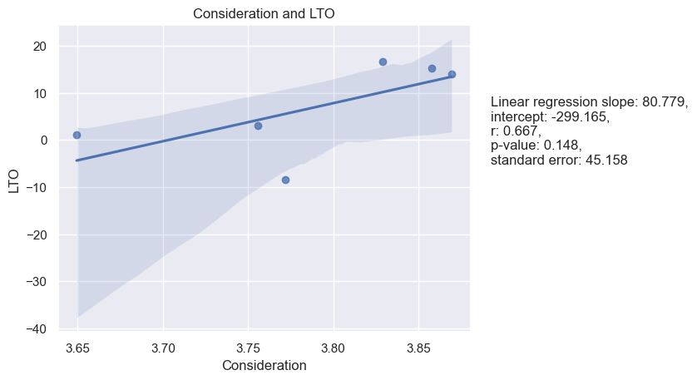

Figure 55. Consideration and Indulgence

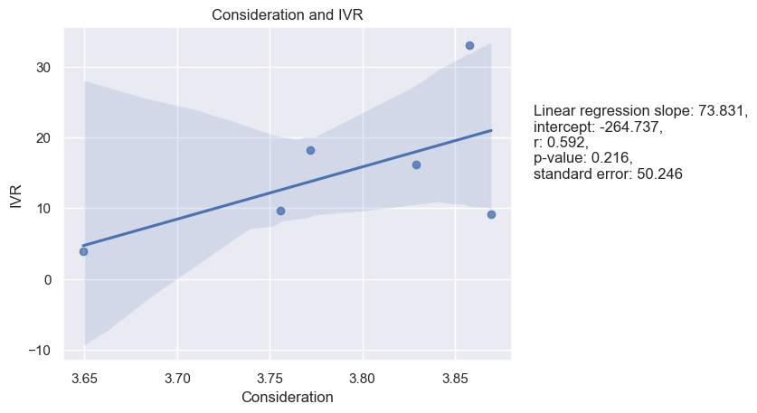

Figure 56. Consideration and Monumentalism

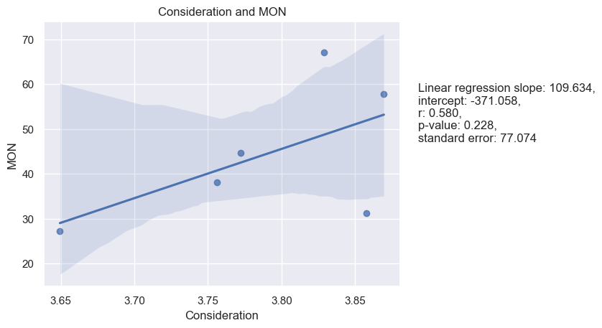

**Production Emphasis and Hofstede’s dimensions**

Production Emphasis and LTO have a Pearson correlation coefficient of 0.83 with a p-value of 0.04, indicating a strong positive correlation between the two variables. The Spearman correlation coefficient is also positive at 0.71, although the p-value is not significant at 0.11. The linear regression model has a slope of 142.819 and an intercept of -516.951. The r value of 0.834 indicates a strong positive correlation, and the p-value of 0.039 is significant. There were no significant relationships found between Production Emphasis and PDI, IDV, MAS, UAI, IVR, and MON. See Table 13.

|  |  |  |  |  |
| --- | --- | --- | --- | --- |
| Table 13. |  | |  | Production Emphasis |
| Spearman and Pearson Correlations between means of Hofstede’s cultural dimensions and of LBDQ’s Production Emphasis in six Federal Districts | | Power Distance | Pearson’s r | -0.35 |
| P-value | 0.50 |
| Spearman’s rho | -0.31 |
| P-value | 0.54 |
| Individualism | Pearson’s r | -0.62 |
| P-value | 0.19 |
| Spearman’s rho | -0.43 |
| P-value | 0.40 |
|  | | Masculinity | Pearson’s r | -0.63 |
|  | | P-value | 0.18 |
|  | | Spearman’s rho | 0.26 |
|  | | P-value | 0.62 |
|  | | Uncertainty Avoidance | Pearson’s r | -0.06 |
|  | | P-value | 0.90 |
|  | | Spearman’s rho | 0.09 |
|  | | P-value | 0.87 |
|  | | Long-Term Orientation | Pearson’s r | 0.83 |
|  | | P-value | 0.04 |
|  | | Spearman’s rho | 0.71 |
|  | | P-value | 0.11 |
|  | | Indulgence | Pearson’s r | -0.20 |
|  | | P-value | 0.70 |
|  | | Spearman’s rho | -0.26 |
|  | | P-value | 0.62 |
|  | | Monumentalism | Pearson’s r | 0.41 |
|  | | P-value | 0.42 |
|  | | Spearman’s rho | 0.60 |
|  | | P-value | 0.21 |

Linear regression analysis was performed as well. See Figures 57-63:

Figure 57. Production Emphasis and Power Distance

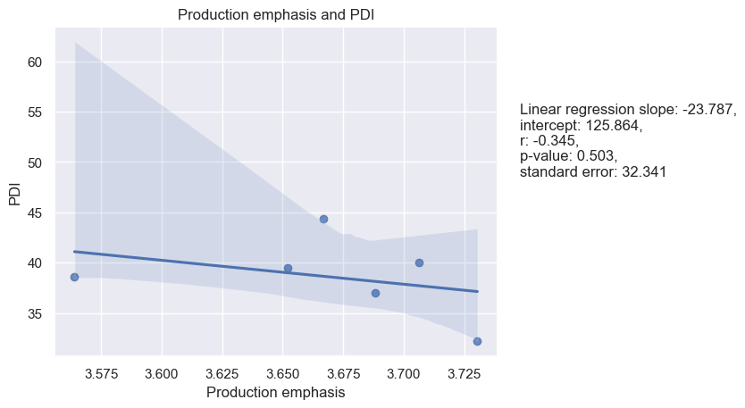

Figure 58. Production Emphasis and Individualism

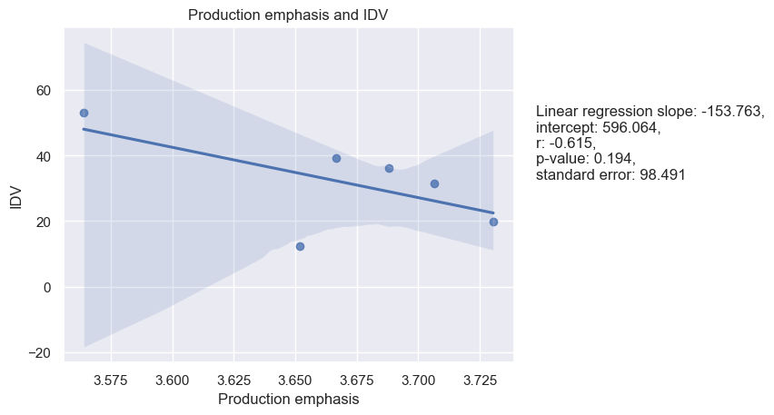

Figure 59. Production Emphasis and Masculinity

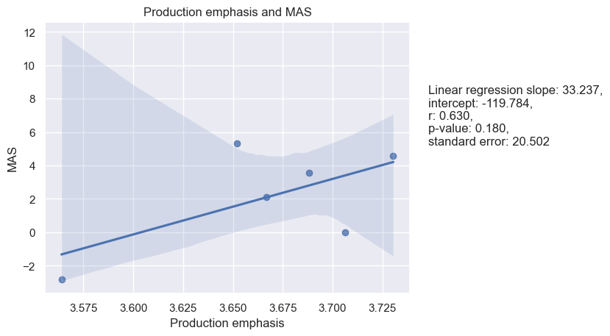

Figure 60. Production Emphasis and Uncertainty Avoidance

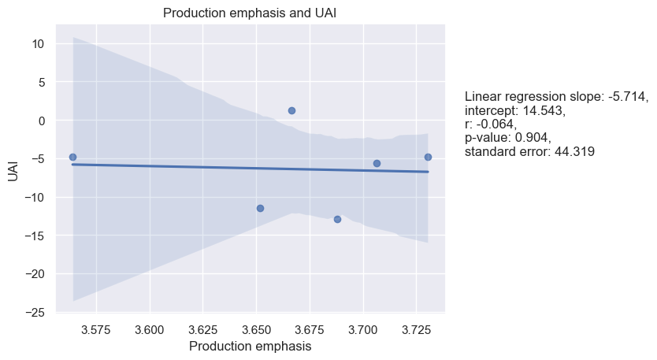

Figure 61. Production Emphasis and Long-Term Orientation

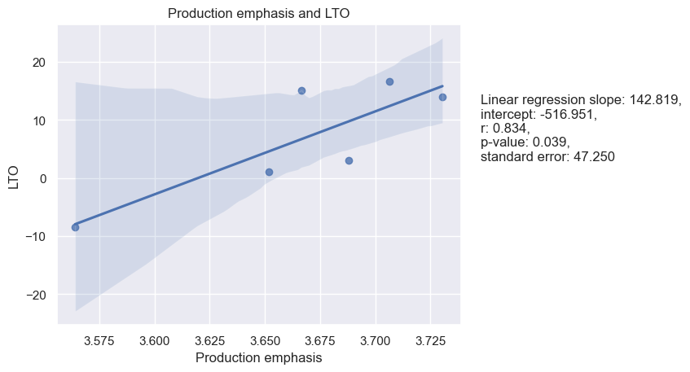

Figure 62. Production Emphasis and Indulgence

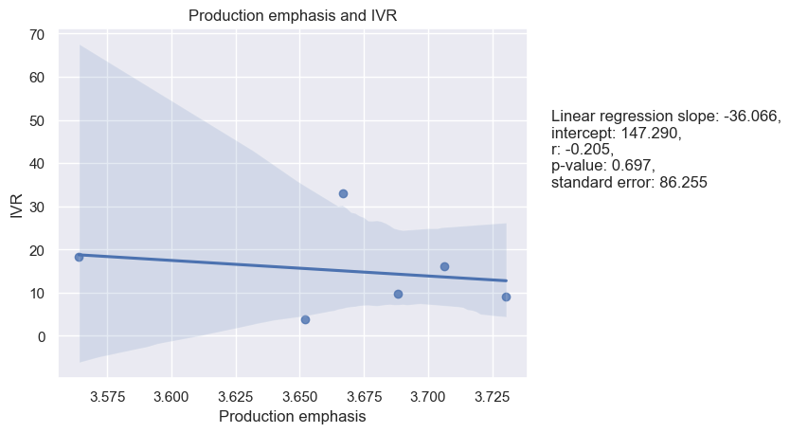

Figure 63. Production Emphasis and Monumentalism

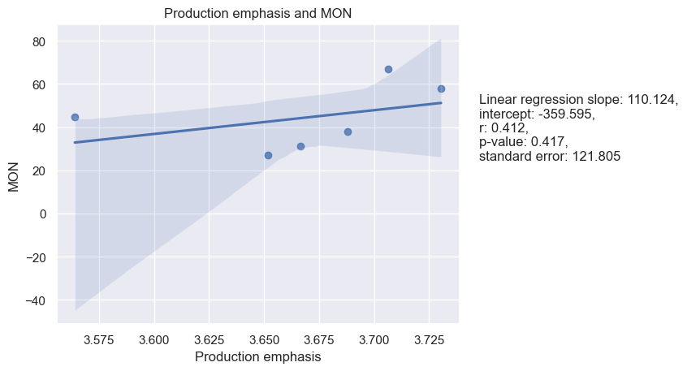

**Prediction Accuracy and Hofstede’s dimensions**

Based on the given results, we can see that the correlations between predictive accuracy and most of Hofstede's cultural dimensions are not statistically significant, with p-values greater than 0.05. However, there is a significant correlation between predictive accuracy and MAS with a Pearson correlation of -0.90 and a p-value of 0.01, as well as a Spearman correlation of -0.83 and a p-value of 0.04. The linear regression model also shows a significant negative relationship between these two variables, with a slope of -30.331 and an intercept of 118.795. See Table 14.

|  |  |  |  |  |
| --- | --- | --- | --- | --- |
| Table 14. |  | |  | Prediction Accuracy |
| Spearman and Pearson Correlations between means of Hofstede’s cultural dimensions and of LBDQ’s Prediction Accuracy in six Federal Districts | | Power Distance | Pearson’s r | 0.07 |
| P-value | 0.90 |
| Spearman’s rho | -0.03 |
| P-value | 0.96 |
| Individualism | Pearson’s r | 0.69 |
| P-value | 0.13 |
| Spearman’s rho | 0.54 |
| P-value | 0.27 |
|  | | Masculinity | Pearson’s r | -0.90 |
|  | | P-value | 0.01 |
|  | | Spearman’s rho | -0.73 |
|  | | P-value | 0.04 |
|  | | Uncertainty Avoidance | Pearson’s r | 0.56 |
|  | | P-value | 0.25 |
|  | | Spearman’s rho | 0.43 |
|  | | P-value | 0.40 |
|  | | Long-Term Orientation | Pearson’s r | 0.02 |
|  | | P-value | 0.98 |
|  | | Spearman’s rho | 0.09 |
|  | | P-value | 0.87 |
|  | | Indulgence | Pearson’s r | 0.47 |
|  | | P-value | 0.35 |
|  | | Spearman’s rho | 0.54 |
|  | | P-value | 0.27 |
|  | | Monumentalism | Pearson’s r | 0.66 |
|  | | P-value | 0.16 |
|  | | Spearman’s rho | 0.77 |
|  | | P-value | 0.07 |

Linear regression analysis for the samples as well as a visualization of the regression models are presented below (see figures 64-70):

Figure 64. Prediction Accuracy and Power Distance

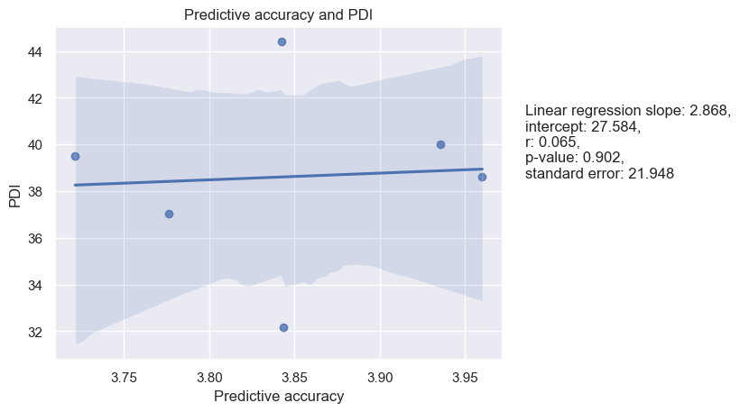

Figure 65. Prediction Accuracy and Individualism

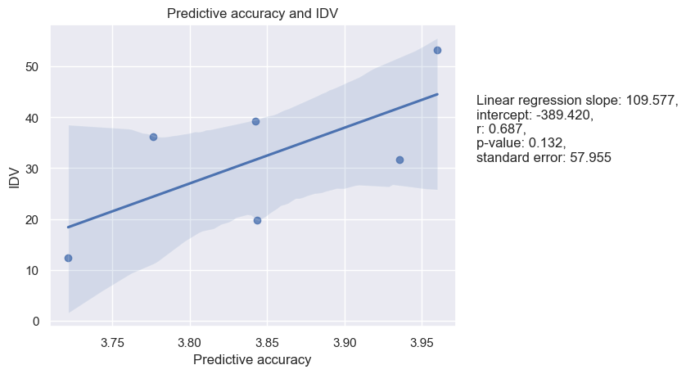

Figure 66. Prediction Accuracy and Masculinity

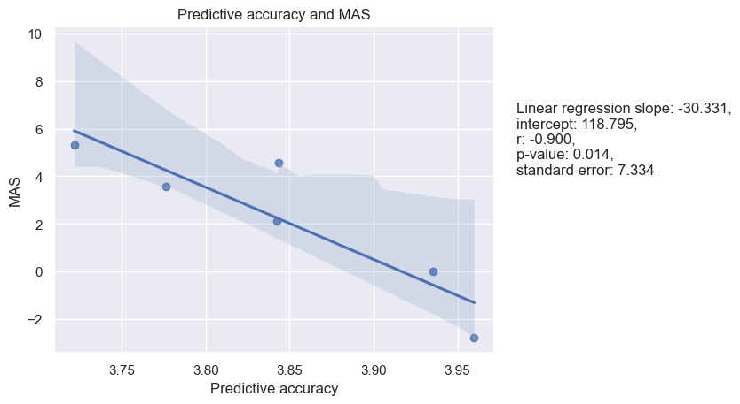

Figure 67. Prediction Accuracy and Uncertainty Avoidance

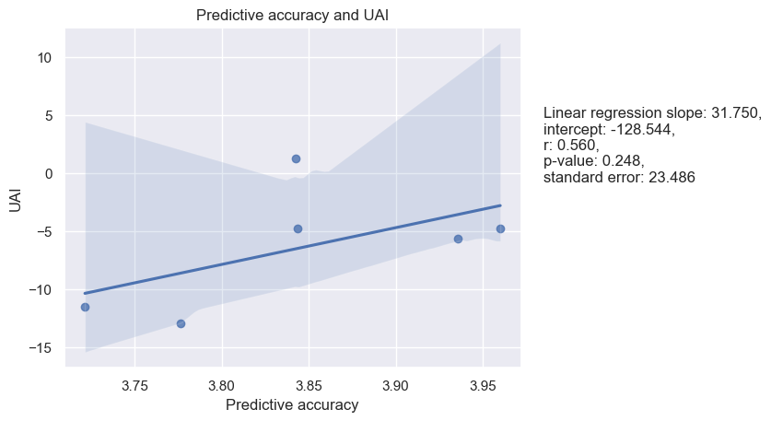

Figure 68. Prediction Accuracy and Long-Term Orientation.

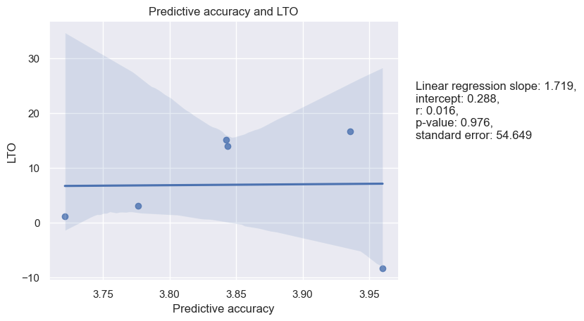

Figure 69. Prediction Accuracy and Indulgence

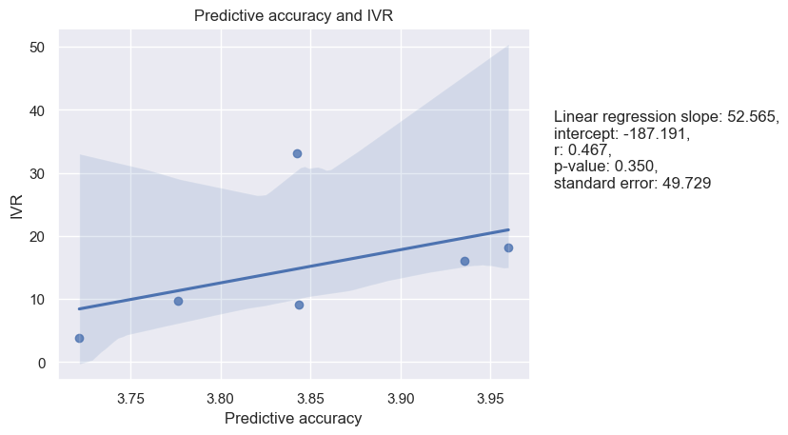

Figure 70. Prediction Accuracy and Monumentalism

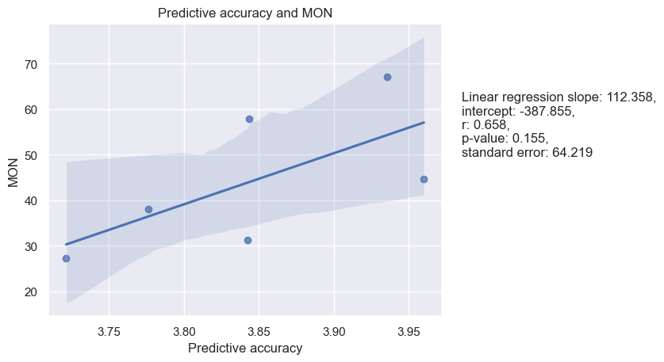

**Integration and Hofstede’s dimensions**

The correlation analysis shows that there is a significant negative correlation between Integration and MON (Pearson r = -0.86, p = 0.03; Spearman rho = 0.94, p = 0.00). This indicates that as the Integration of a leader increases, the Masculinity of the culture decreases, i.e., the culture becomes more feminine. The linear regression model also confirms this relationship as the regression slope is negative and statistically significant (slope = 92.548, p = 0.027). However, the relationship between Integration and IDV, UAI, IVR, PDI, LTO and MAS are not significant. See Table 15.

|  |  |  |  |  |
| --- | --- | --- | --- | --- |
| Table 15. |  | |  | Integration |
| Spearman and Pearson Correlations between means of Hofstede’s cultural dimensions and of LBDQ’s Integration in six Federal Districts | | Power Distance | Pearson’s r | -0.68 |
| P-value | 0.14 |
| Spearman’s rho | -0.49 |
| P-value | 0.33 |
| Individualism | Pearson’s r | -0.18 |
| P-value | 0.73 |
| Spearman’s rho | 0.03 |
| P-value | 0.96 |
|  | | Masculinity | Pearson’s r | 0.02 |
|  | | P-value | 0.97 |
|  | | Spearman’s rho | -0.31 |
|  | | P-value | 0.54 |
|  | | Uncertainty Avoidance | Pearson’s r | 0.23 |
|  | | P-value | 0.66 |
|  | | Spearman’s rho | 0.26 |
|  | | P-value | 0.62 |
|  | | Long-Term Orientation | Pearson’s r | 0.53 |
|  | | P-value | 0.28 |
|  | | Spearman’s rho | 0.31 |
|  | | P-value | 0.54 |
|  | | Indulgence | Pearson’s r | -0.15 |
|  | | P-value | 0.78 |
|  | | Spearman’s rho | 0.03 |
|  | | P-value | 0.96 |
|  | | Monumentalism | Pearson’s r | 0.86 |
|  | | P-value | 0.03 |
|  | | Spearman’s rho | 0.94 |
|  | | P-value | 0.00 |

Linear regression analysis as well as its representation are presented below. See Figures 71-77.

Figure 71. Integration and Power Distance.

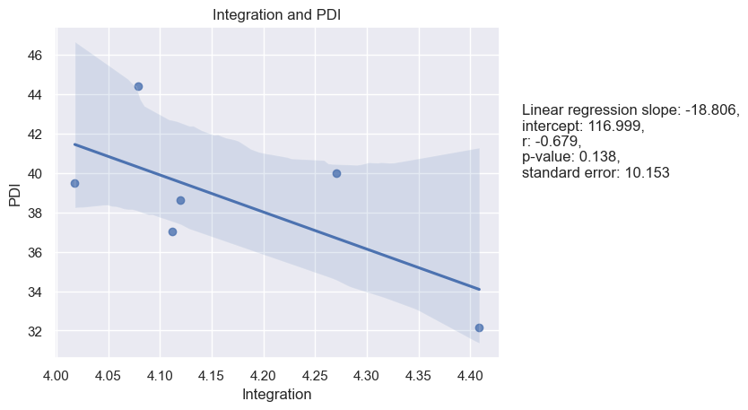

Figure 72. Integration and Individualism

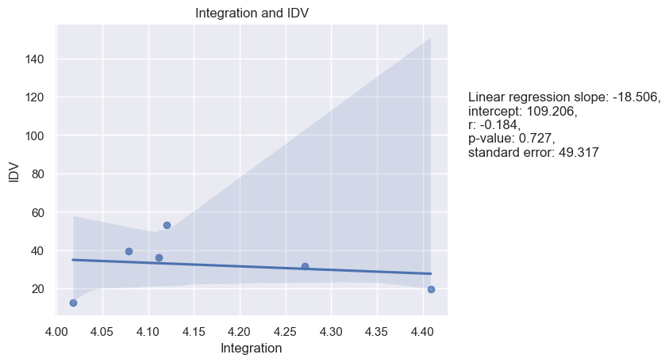

Figure 73. Integration and Masculinity

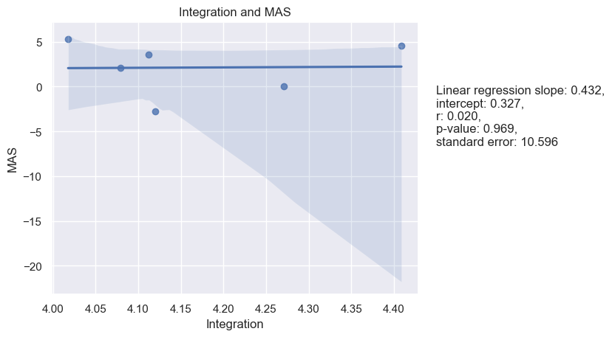

Figure 74. Integration and Uncertainty Avoidance

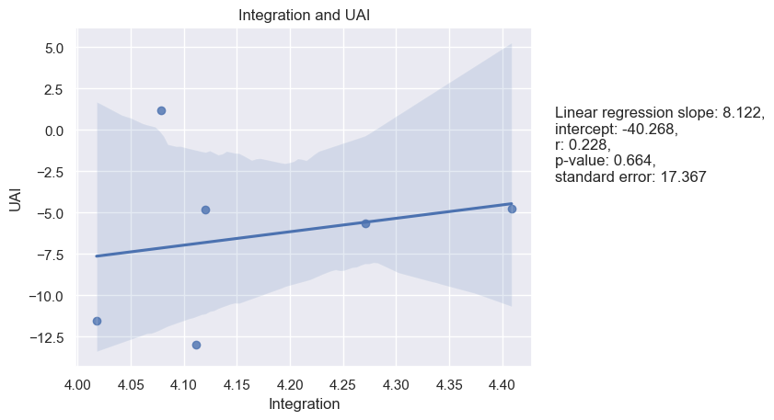

Figure 75. Integration and Long-Term Orientation

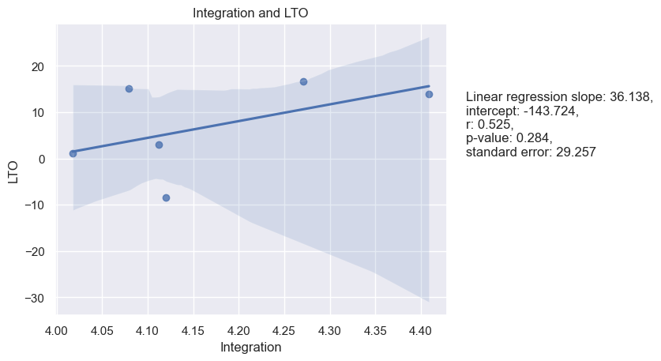

Figure 76. Integration and Indulgence

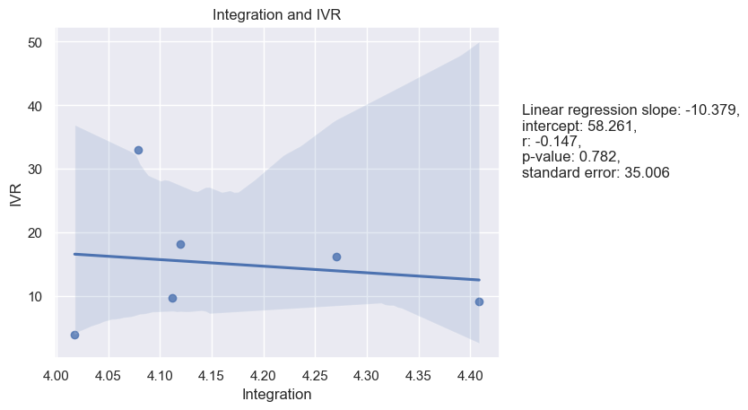

Figure 77. Integration and Monumentalism

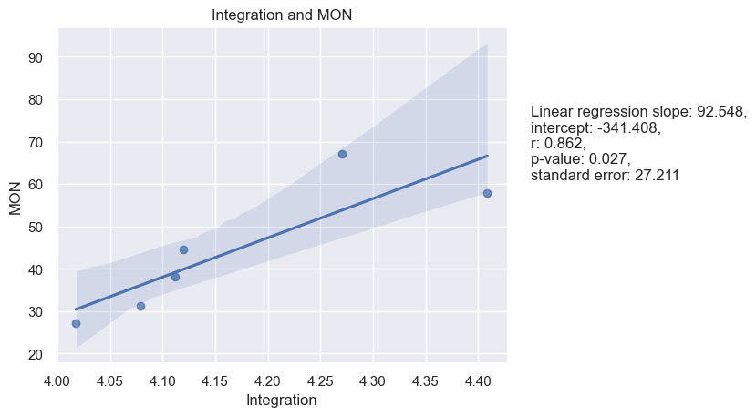

**Superior Orientation and Hofstede’s dimensions**

Based on the provided results, it seems that there are no statistically significant relationships between Superior Orientation and Hofstede's cultural dimensions, as all p-values are greater than the commonly accepted significance level of 0.05. See Table 16.

|  |  |  |  |  |
| --- | --- | --- | --- | --- |
| Table 16. |  | |  | Superior Orientation |
| Spearman and Pearson Correlations between means of Hofstede’s cultural dimensions and of LBDQ’s Superior Orientation in six Federal Districts | | Power Distance | Pearson’s r | -0.60 |
| P-value | 0.21 |
| Spearman’s rho | -0.71 |
| P-value | 0.11 |
| Individualism | Pearson’s r | 0.38 |
| P-value | 0.45 |
| Spearman’s rho | 0.37 |
| P-value | 0.47 |
|  | | Masculinity | Pearson’s r | -0.51 |
|  | | P-value | 0.30 |
|  | | Spearman’s rho | -0.37 |
|  | | P-value | 0.47 |
|  | | Uncertainty Avoidance | Pearson’s r | -0.32 |
|  | | P-value | 0.54 |
|  | | Spearman’s rho | -0.31 |
|  | | P-value | 0.54 |
|  | | Long-Term Orientation | Pearson’s r | -0.58 |
|  | | P-value | 0.23 |
|  | | Spearman’s rho | -0.54 |
|  | | P-value | 0.27 |
|  | | Indulgence | Pearson’s r | -0.40 |
|  | | P-value | 0.43 |
|  | | Spearman’s rho | -0.03 |
|  | | P-value | 0.96 |
|  | | Monumentalism | Pearson’s r | 0.46 |
|  | | P-value | 0.35 |
|  | | Spearman’s rho | 0.43 |
|  | | P-value | 0.40 |

Linear regression analysis was utilized for the samples as well as a visualization of the regression models was performed to better understand the results (see figures 78-84):

Figure 78. Superior Orientation and Power Distance

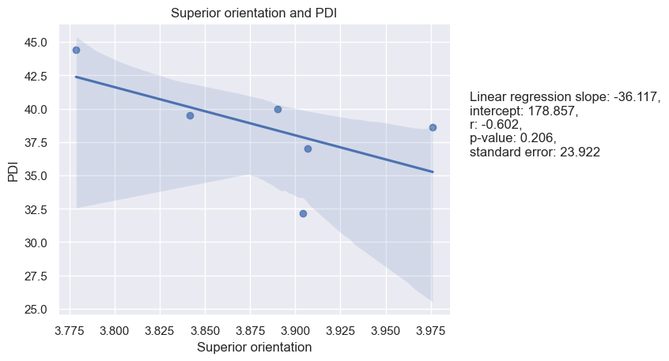

Figure 79. Superior Orientation and Individualism

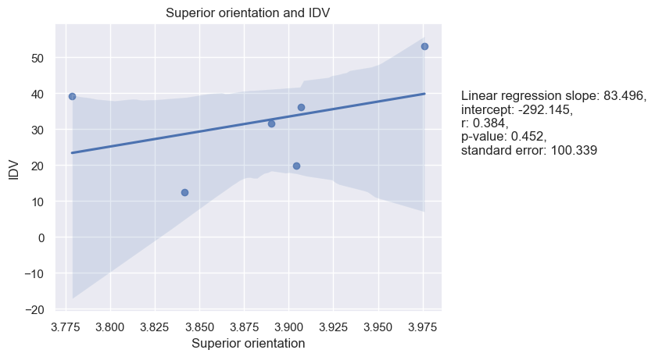

Figure 80. Superior Orientation and Masculinity

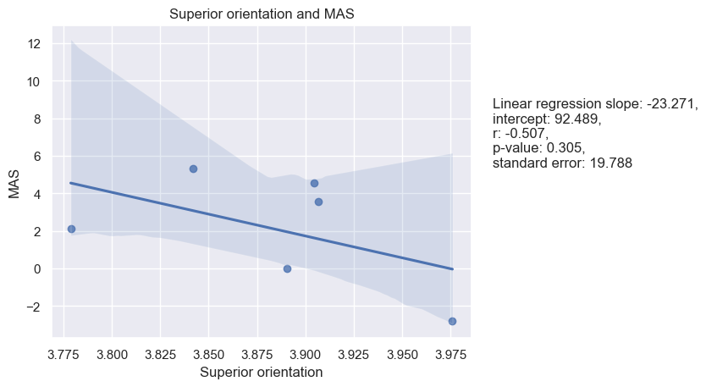

Figure 81. Superior Orientation and Uncertainty Avoidance

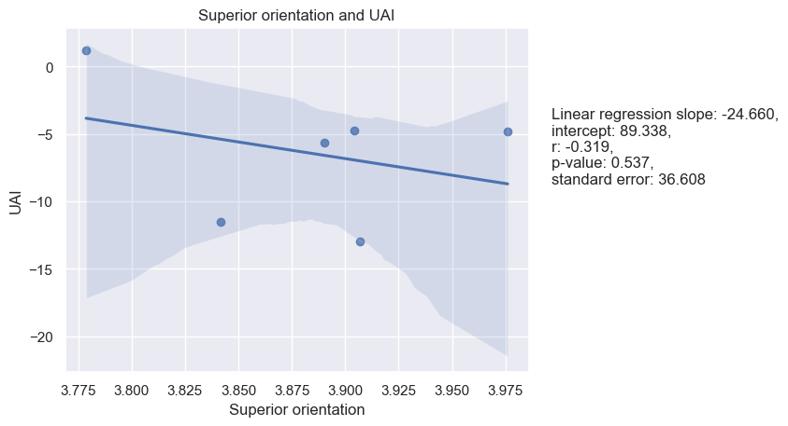

Figure 82. Superior Orientation and Long-Term Orientation

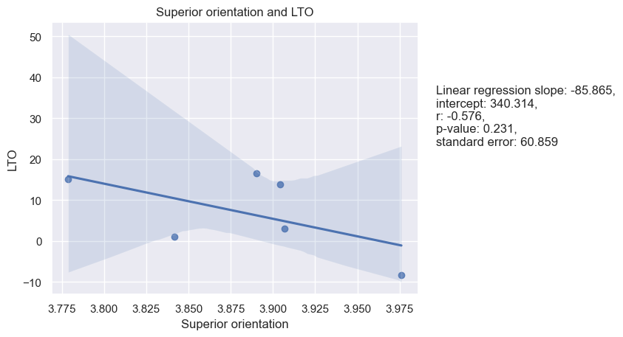

Figure 83. Superior Orientation and Indulgence

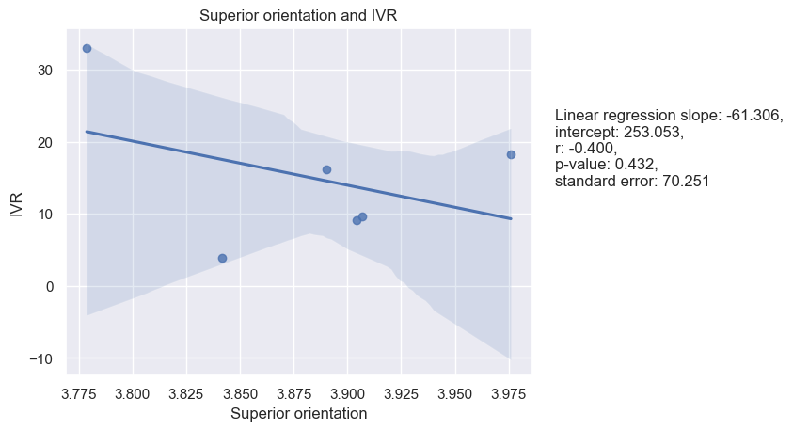

Figure 83. Superior Orientation and Indulgence

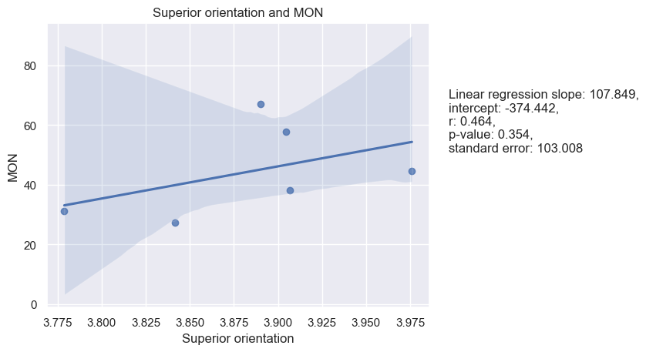

As previously mentioned, the samples used in the analysis were constrained to certain federal districts of Russia due to the limited number of responses received. This could introduce some degree of randomness to the results. However, the study still offers valuable insights into the correlation between cultural values and leader behavior preferences across various regions of Russia. It is important to note that the results presented in Table 17 and Table 18 are applicable to the entire sample of respondents from Russia, and not just the selected six federal districts that were the focus of the analysis.

|  |  |  |  |
| --- | --- | --- | --- |
| Table 17. |  | | Mean Score / Russia |
| Mean scores for Hofstede’s dimensions in overall sample in Russia | | Power Distance | 43.3 |
| Individualism | 32.1 |
| Masculinity | 4.9 |
| Uncertainty Avoidance | -11.4 |
| Long-Term Orientation | 9.0 |
| Indulgence | 9.9 |
| Monumentalism | 44.2 |

|  |  |  |  |
| --- | --- | --- | --- |
| Table 18. |  | | Mean Score / Russia |
| Mean scores for LBDQ’s dimensions in overall sample in Russia | | Representation | 3.7 |
| Reconciliation | 3.7 |
| Tolerance of Uncertainty | 3.4 |
| Persuasiveness | 3.9 |
| Initiation of Structure | 4.0 |
| Tolerance of Freedom | 3.5 |
| Role Assumption | 3.7 |
|  | | Consideration | 3.7 |
|  | | Production Emphasis | 3.7 |
|  | | Prediction Accuracy | 3.9 |
|  | | Integration | 4.1 |
|  | | Superior Orientation | 3.9 |

**Discussion**

Summarizing the thesis, it is safe to say that the questions posed at the beginning of the study have been answered: the relationship between cultural values and preferred leader behavior in six federal districts exists among certain concepts, but most often it is marginal and not significant. Despite this, there are still significant correlations between a number of dimensions, for example Monumentalism and Integration, Masculinity and Prediction Accuracy, Uncertainty Avoidance and Consideration, Long-Term Orientation and Production Emphasis, Monumentalism and Initiation of Structure, Monumentalism and Persuasiveness, Power Distance and Persuasiveness, Masculinity and Tolerance of Uncertainty.

However, it should be noted that this is based on a single study and that further research is needed to confirm or refute these findings.

*Interpretation of the results*

In relation to the first research question - what is the preferred form of Leader Behavior by employees in Russia - it is not possible to give one specific answer: depending on the federal district in the sample, the preference for leader behavior varies for some dimensions. For example, Demand Reconciliation (Central FD – 3.49, North-Western FD – 3.91, Southern FD - 4.00, Volga FD – 3.61, Ural FD – 3.75, Siberian FD – 3.74) in the Southern FD may have a stronger emphasis on group cohesion and harmony, leading to more demand reconciliation behavior among leaders. Also, Role Assumption score of 3.39 in Central FD may suggest that leaders in this region are less likely to take responsibility for their role in decision-making processes and task assignments, while the score of 3.82 in the Southern FD suggests that leaders in this region are more likely to assume their roles and responsibilities, which could be due to various factors such as a culture of accountability or a strong work ethic.

However, looking at mean values, the following interpretations can be drawn for the overall sample in Russia:

1. **Representation**: **3.7**: This score suggests that the leader is moderately positioned as a spokesman of the collective who is responsible for its actions and decisions. The leader may represent the group in some situations, but may not always take on the responsibility of being the voice of the group.
2. **Reconciliation**: **3.7**: This score indicates that the leader is successful in handling difficult and complex problems, maintains concentration with large amounts of information and detail, and is able to organize an orderly and systematic approach to a problem when necessary. The leader may occasionally struggle with difficult voluminous tasks, but overall, the leader is able to deal with conflict and disorder in the system.
3. **Tolerance of Uncertainty: 3.4**: This score suggests that the leader may sometimes react nervously and anxiously to unforeseen events, easily gets out of a state of calm, and gets frustrated when things do not work right. The leader may need to work on resisting anxiety and disorientation in situations of uncertainty, to remain calm and rational when things do not go as planned.
4. **Persuasiveness: 3.9**: This score indicates that the leader is generally persuasive, argumentative, and convincing. The leader is able to persuade, motivate, and successfully justify his or her point of view. However, there may be some situations where the leader lacks persuasive skills and fails to instill his or her ideas in subordinates and compel them to action.
5. **Initiation of Structure: 4.0**: This score suggests that the leader is actively involved in organizing and formalizing the work process, scheduling, and distributing responsibilities. The leader always clearly and explicitly expresses his or her requirements and expectations, encourages standardized procedures and implementation of new ideas.
6. **Tolerance of Freedom: 3.5**: This score indicates that the leader provides some level of permissiveness, initiative, freedom in decision making, and problem-solving to employees under his or her guidance. However, there may be some limitations in the scope of empowerment during the execution of work objectives.
7. **Role Assumption: 3.7**: This score indicates that the leader fulfills the leadership role actively and takes necessary decisions, taking responsibility for any problems and emergencies. The leader is respected and accepted by employees. However, there may be some situations where the leader delegates the leadership role to others.
8. **Consideration: 3.7**: This score suggests that the leader values the comfort, well-being, status, and contributions of the followers. The leader is open in communication, interested in his or her subordinates, and maintains a good, warm, benevolent atmosphere in the team or workplace.
9. **Production Emphasis: 3.7**: This score indicates that the leader prioritizes maximum efficiency, encourages overwork, promotes a high tempo workflow, and motivates to improve prior performance metrics. However, the leader may not always be focused on high productivity and may allow the group to work at their own pace without forcing them to work at their maximum capacity.
10. **Prediction Accuracy: 3.9**: This score indicates that the leader has the ability to predict the outcome of events with high accuracy, to look ahead and anticipate the result that was originally intended. The leader is often correct in his or her ideas about the future and is likely to predict certain trends, which can help avoid unwelcome consequences.
11. **Integration: 4.1**: This score indicates that the leader is successful in maintaining peace in the team, resolving misunderstandings and conflicts when they arise, and establishing close-knit relationships between employees. The leader controls and provides the appropriate atmosphere in the workplace, and encourages subordinates to build relationships within the group
12. **Superior Orientation: 3.9**: such score suggests that the leader is moderately interested in building positive relationships with their superiors, aspiring to higher status, and exerting some level of influence over top-level decision making. This leader likely seeks to impress their superiors and advance their own career, but may not prioritize these goals over the needs of their team and organization as a whole.

With regard to the second question, namely what are the current scores of the Hofstede’s dimensions in Russia, Hofstede's research considered the indices obtained for all dimensions in relation to countries as a whole, rather than the country's regions, so to answer the research question posed it would be reasonable to compare the average index for Russia of this study, rather than to show separately the scores for selected federal districts. Hence, one can conclude that Hofstede's Power Distance index does not fully correspond to the contemporary realities of Russian society and its inherent cultural values.

1. **Power Distance: 43.3** - This score suggests that in Russia, there is a moderate acceptance of unequal distribution of power and authority within society. This means that people in positions of power are expected to use their authority and make decisions, but they are also expected to consult with and consider the opinions of those lower in the hierarchy. This score is lower than the previous score for Russia, which indicates that there has been aт increase in egalitarianism in the society.
2. **Individualism: 32.1** - This score suggests that Russia is a collectivist society where people value group harmony and cooperation over individual achievement and competition. People in such societies tend to prioritize their family, friends, and social groups over their own personal goals. This score is also slightly lower than the previous score for Russia, indicating a slight increase in collectivism.
3. **Masculinity: 4.9** - This score suggests that Russia is a feminine society where there is a lower emphasis on traditional male roles, such as assertiveness and competitiveness. People in such societies tend to value nurturing and caring behaviors and prioritize the quality of life over material possessions. This score is significantly lower than the previous score for Russia, which suggests a significant shift towards femininity in the society.
4. **Uncertainty Avoidance: -11.4** - This score suggests that Russia is a society that is comfortable with ambiguity and uncertainty. People in such societies tend to be more open to new ideas and more tolerant of diverse opinions and beliefs. This score is significantly lower than the previous score for Russia, indicating a significant shift towards tolerance and openness.
5. **Long-Term Orientation: 9.0** - This score suggests that Russia tends to have a more short-term focus in its societal values and norms. This could manifest in a number of ways, such as a preference for quick results and immediate gratification over long-term planning and investment, a lower emphasis on tradition and persistence, and a higher tolerance for risk-taking and change. The score is significantly lower than the previous score, highlighting the shift in the mindset of the Russian society.
6. **Indulgence: 9.9** - This score suggests that Russia tends to suppress gratification of needs and regulate it through strict social norms. Russians tend to be more conservative and traditional, and they place a higher value on maintaining social order and stability. They may have a tendency towards cynicism and pessimism, and may view life as a difficult and challenging experience that requires discipline and self-control. The obtained score is slightly lower than Hofstede’s one.
7. **Monumentalism: 44.2** - This score suggests that Russia is a society that values grandeur, symbolism, and the display of power and wealth over humility, modesty, and egalitarianism. People in such societies tend to value the display of impressive monuments and buildings, as well as other grand displays of power and wealth. This score is significantly higher than the previous score for Russia, indicating a significant increase in the society's focus on monumentalism.

Overall, the newly retrieved indices suggest that Russia has experienced some significant changes in its cultural dimensions over time. The society has become slightly more egalitarian, collectivist, and focused on short-term goals, while also becoming significantly more feminine, tolerant, and focused on restraint and monumentalism values. These changes may be due to a variety of factors, such as shifts in social and economic conditions, changes in government policies, and the influence of global cultural trends.

To answer the third question - what is the relationship between cultural values and preferences for leader behavior, it is necessary to look at the results of the statistical analysis of the data obtained between 7 Hofstede's dimensions and 12 LBDQ's dimensions of preferred leader behavior in six federal regions of Russia. It provides interesting insights into the relationship between cultural dimensions and leadership behavior. Although only 8 out of 84 correlations were found to be strong and significant, it is important to note that negative or weak correlations can also be valuable and informative for further research. In this case, the non-significant results suggest that there may not be a strong relationship between certain cultural dimensions and preferred leader behavior in these specific regions of Russia. However, this does not necessarily mean that the relationship does not exist in other contexts or that it is not worth exploring further.

Explanations of the significant relationships are the following:

1. The strong positive correlation between LBDQ's Integration dimension and Hofstede's Monumentalism dimension in the six federal districts in Russia may suggest that there is a cultural preference for leaders who can both assert their authority and foster team cohesion. In cultures with high scores on Hofstede's Monumentalism dimension, leadership is often characterized by a strong and assertive leader who commands respect and authority. On the other hand, cultures that score high on LBDQ's Integration dimension value leaders who foster teamwork, collaboration, and open communication. The positive correlation between these two dimensions in the Russian context suggests that Russian culture values leaders who are both assertive and collaborative. One possible explanation for this cultural preference could be the legacy of the Soviet era in Russia. During this time, there was a strong emphasis on collectivism and obedience to authority, as well as a need for strong leadership to mobilize resources and achieve common goals.
2. The analysis indicates a strong negative correlation between the LBDQ's dimension of Prediction Accuracy and Hofstede's Masculinity dimension in the six federal districts of Russia. This means that as the score for Masculinity increases, the score for Prediction Accuracy decreases and vice versa. One possible cultural explanation for this result is that in regions with higher scores in Masculinity, there may be a greater emphasis on competitiveness, assertiveness, and achievement, while in regions with lower scores in Masculinity, there may be a greater emphasis on cooperation, teamwork, and nurturing. This may lead to differences in preferences for leadership behavior, with individuals in more masculine societies preferring leaders who are more task-oriented and directive, while individuals in less masculine societies preferring leaders who are more relationship-oriented and participative. On the other hand, the LBDQ's dimension of Prediction Accuracy measures the ability of leaders to accurately predict the outcomes of their decisions and actions. It is possible that in more masculine societies, leaders may be more focused on achieving immediate goals and may not take the time to accurately predict the long-term consequences of their actions, leading to lower scores in Prediction Accuracy. In less masculine societies, leaders may be more focused on building and maintaining relationships, which may involve more careful consideration of the potential outcomes of their decisions, leading to higher scores in Prediction Accuracy.
3. There is a significant positive correlation between the LBDQ's Production Emphasis dimension and Hofstede's Long-Term Orientation (LTO) dimension in this case. One possible explanation for this relationship could be that a federal district that values long-term goals and planning would naturally place a greater emphasis on production and efficiency in order to achieve those goals. In contrast, federal districts that place less emphasis on long-term planning may be more focused on immediate results and less concerned with productivity and efficiency. It is worth noting that the Spearman correlation coefficient, although still positive, is lower than the Pearson correlation coefficient, and the p-value is also higher, indicating that the relationship between Production Emphasis and LTO may not be as consistent across all districts, and there may be some variability in the relationship depending on the specific district.
4. The correlation between Initiation of Structure and Monumentalism in the six federal districts in Russia seems to be significant. A higher score in Initiation of Structure indicates that leaders in these districts tend to be more directive, task-oriented, and focused on achieving goals. On the other hand, a higher score in Monumentalism suggests that there is a greater emphasis on the importance of status, hierarchy, and respect for authority in these districts. The positive correlation between these two dimensions suggests that leaders in districts with higher Monumentalism scores are also likely to be more directive and focused on achieving goals. One possible explanation for this could be that in cultures with a strong emphasis on hierarchy and authority, there is a greater expectation for leaders to take charge and direct their subordinates. Additionally, in such cultures, leaders are expected to maintain the status quo and avoid any actions that could be seen as a challenge to the existing power structure. Therefore, leaders in these cultures may be more focused on achieving goals and maintaining order, which is reflected in their higher scores on Initiation of Structure.
5. There is a positive correlation between Consideration and Uncertainty Avoidance, as shown by the Pearson correlation coefficient of 0.75 and the Spearman correlation coefficient of 0.83. This suggests that in districts with higher scores in Uncertainty Avoidance, there may be a greater emphasis on interpersonal relationships, empathy, and concern for others, as captured by the Consideration dimension. One possible cultural explanation for this result is that in societies with high levels of Uncertainty Avoidance, there is a greater need for predictability, stability, and order, which may result in a focus on group harmony and the development of strong social norms and relationships. This may in turn foster a greater concern for others and a focus on maintaining good relationships, as captured by the Consideration dimension. It is also possible that the emphasis on interpersonal relationships and empathy may help to reduce uncertainty and increase feelings of security and stability in uncertain environments. The Pearson’s p-value is slightly above 0.05, which means that the observed relationships may be due to chance. However, it's still possible that there is a meaningful relationship between the variables that is worth further investigation or consideration.
6. The positive correlation between Persuasion and Monumentalism suggests that in districts with higher scores in Monumentalism, there may be a greater emphasis on assertiveness, persuasiveness, and the ability to influence others, as captured by the Persuasion dimension. One possible cultural explanation for this result is that in societies with high levels of Monumentalism, there is a greater focus on the importance of hierarchy, authority, and power, which may result in a need for individuals to assert their own influence and demonstrate their persuasive abilities. This may be especially true in more formal organizational settings, where persuasion and assertiveness may be necessary for individuals to navigate complex power structures and achieve their goals. It is also possible that the emphasis on persuasion and influence may be related to the desire to achieve impressive, monumental accomplishments that are valued in societies with high levels of Monumentalism.
7. Also, there is a negative correlation between Persuasiveness and Power Distance, as shown by the Pearson correlation coefficient of -0.81 and the Spearman correlation coefficient of -0.54. This suggests that in districts with higher scores in Power Distance, there may be less emphasis on persuasion and influencing others. One possible cultural explanation for this result is that in societies with high levels of Power Distance, there is a greater acceptance of hierarchical structures and authority, which may result in a reduced need for persuasion and influence. This may also result in less emphasis on individualistic behavior and more emphasis on group cohesion and collective decision-making, which may also reduce the need for persuasion. However, the Spearman’s p-value of 0.27 suggest that the relationship may not be significant when considering non-linear associations.
8. Based on the statistical analysis, there is a strong negative correlation between Tolerance of Uncertainty and Masculinity, as shown by the Pearson correlation coefficient of -0.82 and the Spearman correlation coefficient of -0.71. This suggests that in districts with higher scores in Masculinity, there may be a lower tolerance for uncertainty and ambiguity. One possible cultural explanation for this result is that in societies with high levels of Masculinity, there may be a greater emphasis on competition, achievement, and assertiveness, which may lead to a lower tolerance for ambiguity and uncertainty. On the other hand, in societies with lower levels of Masculinity, there may be a greater emphasis on cooperation, collaboration, and nurturing, which may foster a greater tolerance for ambiguity and uncertainty.

Overall, the results of the analysis provide some insights into the relationship between Hofstede's cultural dimensions and preferred leader behavior in the regions of Russia that were studied. While there were only a small number of significant correlations, these findings can still be useful for guiding future research and for gaining a better understanding of how cultural factors influence leadership. It is important to keep in mind that these results are limited to the specific regions and dimensions studied, and may not be generalizable to other contexts or populations. As such, it would be valuable to conduct further research in this area to confirm and expand upon these findings.

**Contributions to the literature and theoretical implications**

The present study contributes to the existing literature by shedding light on the relationship between Hofstede's cultural dimensions and the Stogdill’s dimensions of preferred leader behavior in the context of six federal regions in Russia. By analyzing 84 correlations, the study identified eight significant and strong correlations, which provide valuable insights into the complex interplay between cultural values and leadership preferences as well as it expands the current knowledge base of cross-cultural leadership research by providing insights into how leadership behaviors are perceived and practiced in this unique cultural context.

One of the key contributions is that the study provides empirical evidence on the relationship between Hofstede's cultural dimensions and LBDQ's dimensions of preferred leader behavior in Russia. This is important because there is limited research that has investigated the relationship between these two constructs in Russia, despite its importance in understanding leadership behavior in the country. Thus, this study adds to the body of literature on leadership behavior in Russia and provides a basis for further research in this area.

The study's findings also have theoretical implications for both Hofstede's cultural dimensions and the Stogdill’s dimensions of preferred leader behavior. The significant correlations found provide empirical evidence that supports the theoretical framework of both constructs. For example, the significant positive correlation between Uncertainty Avoidance and Consideration dimensions supports the idea that in societies with high levels of uncertainty avoidance, there is a greater need for predictability, stability, and order, which may result in a focus on group harmony and the development of strong social norms and relationships, as captured by the Consideration dimension.

Moreover, the significant negative correlation between Power Distance and Persuasiveness dimensions suggests that in societies with low power distance, leaders may not rely on persuasion tactics as much as they do in societies with high power distance. This finding supports the theoretical assumption that in societies with high power distance, there is a greater acceptance of unequal distribution of power, and leaders may use persuasion tactics to maintain their authority and influence.

Overall, this study's findings have theoretical implications for understanding leadership behavior in Russia and contribute to the development of the theoretical frameworks of both Hofstede's cultural dimensions and LBDQ's dimensions of preferred leader behavior. Furthermore, the study provides insights that can be useful for both practitioners and policymakers in Russia, as it highlights the importance of cultural factors in leadership behavior and the need to consider these factors when developing leadership programs and policies in the country. The findings of this study can also serve as a basis for future research to explore the relationship between cultural dimensions and leadership behavior in other contexts and countries.

## **Practical implications**

The practical implications of this study can be significant for organizations operating in the regions studied. By understanding the cultural dimensions and preferred leader behaviors, organizations can tailor their leadership styles to better align with the cultural norms and expectations of the region. This can improve the effectiveness of leadership and increase the likelihood of achieving organizational goals.

For example, in regions where there is a strong correlation between Monumentalism and Integration, organizations can focus on building strong relationships with employees and other stakeholders, and promote teamwork and collaboration. Similarly, in regions where there is a strong correlation between Masculinity and Prediction Accuracy, organizations can emphasize the importance of setting and achieving goals, and implement systems and processes to measure and track performance.

Moreover, the findings of this study can be used to inform cross-cultural training and development programs for leaders operating in multiple regions. By understanding the cultural dimensions and preferred leader behaviors in each region, leaders can better adapt to the cultural norms and expectations of the region, build stronger relationships with employees and stakeholders, and improve their effectiveness in leading diverse teams.

In addition, this study can also inform the design of recruitment and selection processes for leaders in these regions. By identifying the cultural dimensions and preferred leader behaviors that are most valued in each region, organizations can recruit and select leaders who are more likely to be successful in the region and fit in with the cultural norms and expectations.

Overall, the practical implications of this study are significant for organizations operating in these regions, as they provide valuable insights into the cultural dimensions and preferred leader behaviors that are most effective in each region. By leveraging this knowledge, organizations can improve their leadership effectiveness, achieve their goals, and create more positive outcomes for employees and other stakeholders.

**Limitations**

While this paper provides valuable insights into the relationship between Hofstede's cultural dimensions and LBDQ's leadership behavior dimensions in Russia, it is important to acknowledge some limitations of the study.

First, the sample size is relatively small, which only amounts to 260 participants, with only six federal regions in Russia included in the study. A larger sample size would have been preferable for a study aiming to make a significant contribution to the scientific field. Unfortunately, due to time and financial constraints, the researcher was unable to collect more data. The data collection period lasted for only three months, which is significantly shorter than that of researchers like Hofstede, who had the luxury of four years to collect data. Although the regions were chosen based on their geographic and demographic diversity, the results may not be generalizable to other regions of Russia.

Second, the data collection was limited to simple distribution methods such as social media, as the researcher did not make use of paid services that could have attracted more participants. The study sample is not representative of the entire population of workers in Russia. The majority of the participants were male (64%), and only 36% were female. The study also included a relatively high proportion of participants from the production sector (37%), which may have influenced the results. Additionally, the study included a high proportion of participants with lower levels of education and job levels, which may limit the generalizability of the findings to other segments of the population. However, despite these limitations, the obtained results still hold some relevance.

Third, the study relied on self-reported measures of both cultural values and preferred leadership behavior, which may introduce bias or social desirability effects. Participants may have overreported their cultural values or leadership behavior to align with social norms or expectations.

Fourth, although the overall sample represents all federal districts, not all regions have sufficient data for separate analysis and comparison with other regions. For instance, the Far East and North-Caucasian regions had the lowest response rates, with only six and four participants, respectively. Therefore, these numbers cannot be considered representative at the regional level. Nevertheless, they were included in the study to determine the country mean scores. The Central region had the highest number of responses (79), whereas the Volga, Ural, and Siberian regions had 59, 31, and 33 responses, respectively. To obtain a comprehensive view of Russia, it would be ideal to collect enough responses in each federal district. Furthermore, there was heterogeneity within the regions themselves, with the majority of responses in the Central Federal District coming from Moscow and the Ural region from Chelyabinsk. In future studies, it would be preferable to collect a more homogeneous and larger number of responses per region to ensure a more representative analysis.